**Plate-Grip Wrist Exercises**

* Use a 5 lbs weight. If weight is to easy you can add more plates; 2.5lbs and 5 lbs.
* Notice the two different grips. Curveball grip (one finger). Fastball grip (two fingers).
* Perform 20 reps of each exercise. Perform with each hand, alternate throwing and non-throwing hand after each exercise to allow your throwing hand to rest before performing the next set.
* Complete the all exercises using Curveball grip, then repeat all exercises using the Fastball grip.

**Horizontal Hammer Flexion (pictured with curveball grip)**

Photo 1 – Starting Position Photo 2 – Finish Position

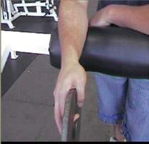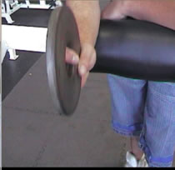

**Inverted Hammer Extension (pictured with curveball grip)**

Photo 1 – Starting Position Photo 2 – Finish Position

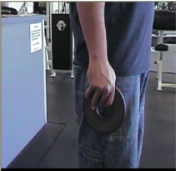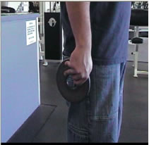

**Wrist Supination and Pronation (pictured with fastball grip)**

Photo 1 – Starting Position Photo 2 – Finish Position

