Section 11.1: Sequences

Introduction:
- A sequence $\left\{a_{n}\right\}$ is a function whose domain is the set of positive integers.
- The functions values $a_{1},a_{2},a_{3},…,a_{n}, …$ are called the terms of the sequence.
- The value of function at the integer $n$ is $a_{n}$.
- The variable $n$ is called the index.

A sequence may be specified in three ways:
- By an explicit formula
$a_{n}=2⋅3^{n}$
- By a recursive formula
$a_{n+1}=3a_{n}, a_{1}=6$
- By giving enough terms to establish a pattern
6, 18, 54, 162, . . .

Graphing a Sequence on the TI-83/84:
1. Press MODE. Select Seq at the end of the fourth line.
2. Press Y= and type the sequence. Use the X,T,θ,n key to get the variable “n.”
3. Adjust the viewing window as necessary.

Example: Graph the sequence $b_{n}=1+\frac{1}{n}$.

The Limit of a Sequence:

Consider the sequence $b_{n}=1+\frac{1}{n}$.
$$b_{1}=2, b_{2}=\frac{3}{2}, b_{3}=\frac{4}{3}, b_{4}=\frac{5}{4}, b_{5}=\frac{6}{5}, b_{6}=\frac{7}{6}$$

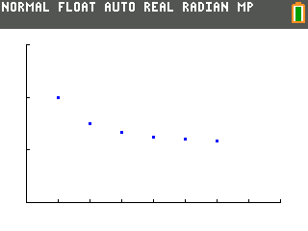

It appears that
$$\lim_{n→∞}{b_{n}}=\lim_{n→∞}\left(1+\frac{1}{n}\right)=1$$

NOTE: All the limit theorems for functions (learned in Calculus I) also apply to sequences.

Definition: If $\lim_{n→∞}{a_{n}=L}$ is finite, then the sequence $\left\{a_{n}\right\}$ converges; if $\lim_{n→∞}{a_{n}=L}$ is infinite or does not exist, then the sequence $\left\{a_{n}\right\}$ diverges.

Observe the if $p$ is a positive number, then
$$\lim_{n→∞}{\frac{1}{n^{p}}}=0$$
Examples: Show the following sequences converge.

1. $a_{n}=\frac{n^{2}+3n}{2n^{2}+1}$

2. $b_{n}=\frac{3n-1}{n+\sqrt{n}}$
Theorem: Let $\left\{a_{n}\right\}$ be a sequence and let f be a function defined on $\left[1,∞\right)$ such that $f\left(n\right)=a_{n}$ for $n=1, 2, 3,…$ n.
If $\lim_{x→∞}{f(x)}=L$, then $\lim_{n→∞}{a_{n}}=L$.

However, it is NOT necessarily true that if $\lim_{n→∞}{a_{n}}=L$, then $\lim_{x→∞}{f(x)}=L$. For example:
If $f\left(x\right)=\sin{πx}$, then $\lim_{x→∞}{\sin{πx}}$ does not exist. See the graph below.

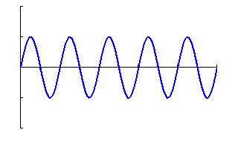
The graph of y = sin πx

If $a_{n}=\sin{πn}$, then $\lim_{n→∞}{\sin{πn}}=0$. This is because $\sin\left(nπ\right)$ is a succession of zeros for
$n=1, 2, 3, …$ . See the graph below.

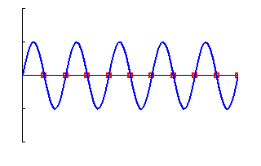
The graph of $a_{n}=\sin{πn}$ (in red)
with $y=\sin{πx}$ (in blue) superimposed.

Example: Does $\left\{\frac{\ln{n}}{e^{n}}\right\}$ converge?
Some Convergence Theorems:

The Squeeze Theorem: Suppose the $\left\{a_{n}\right\}$ and $\left\{c_{n}\right\}$ both converge to L and that $a_{n}≤b_{n}≤c_{n}$ for $n≥K$ (K is a fixed positive integer). Then $\left\{b_{n}\right\}$ converges to L.

Example: Use the Squeeze Theorem to show that $\left\{\frac{\sin^{3}{n}}{n}\right\}$ converges.

The Squeeze Theorem can be used to prove the Absolute Value Theorem stated below.

Absolute Value Theorem: If $\lim_{n→∞}\left|a_{n}\right|=0$, then $\lim_{n→∞}{a_{n}}=0$.

Example: Show that if $-1<r<1$, then the sequence $\left\{r^{n}\right\}$ converges.

Solution:
If $r=0$, $\lim_{n→∞}{0^{n}}=0$. So, we only need to deal with cases when $-1<r<0$ and $0<r<1$; that is, when $0<\left|r\right|<1$.
Since $\left|r\right|<1$, $\frac{1}{\left|r\right|}>1$. Thus, there is some positive number $p$ such that $\frac{1}{\left|r\right|}=1+p$.
Now, we recall the Binomial Formula which says
$${\left(a+b\right)}^{n}=a^{n}+na^{\left(n-1\right)}b+\frac{n\left(n-1\right)}{2!}a^{n-2}b^{2}+\frac{n\left(n-1\right)\left(n-2\right)}{3!}a^{n-3}b^{3}+…+nab^{n-1}+b^{n} \\ =\sum_{k=0}^{n}{\left(\begin{matrix}n \\ k\end{matrix}\right)}a^{n-k}b^{k}$$
Note that: $\left(\begin{matrix}n \\ k\end{matrix}\right)=\frac{n!}{k!\left(n-k\right)!}$.
Using the Binomial Formula, we see that
$$\frac{1}{\left|r^{n}\right|}=\frac{1}{{\left|r\right|}^{n}}={\left(1+p\right)}^{n}=1+np+other positive terms \\ ≥np$$
Hence, we know that
$$0≤\left|r^{n}\right|≤\frac{1}{np}$$
and that
$$\lim_{n-∞}{0}=0 and \lim_{n→∞}{\frac{1}{np}}=0$$
Thus, by the Squeeze Theorem, $\lim_{n→∞}\left|r^{n}\right|=0$. And, by the Absolute Value Theorem, $\lim_{n→∞}{r^{n}}=0$.

Monotonic Sequences:
- A sequence $\left\{a_{n}\right\}$ is called nondecreasing if $a_{n}≤a_{n+1}, n≥1$.
- A sequence $\left\{b_{n}\right\}$ is called nonincreasing if $b_{n}≥b_{n+1}, n≥1$.
- A sequence is called monotonic if it is either nondecreasing or nonincreasing.

Two examples of nondecreasing sequences are
$$a_{n}=n^{2} and b_{n}=1-\frac{1}{n}$$

A nondecreasing sequence can do one of two things:
1. March off to infinity, or
2. If it is bounded above (that is, $a_{n}≤K$ for $n≥1$ and some fixed number K), then it must bump against a “lid.” See the figure below.
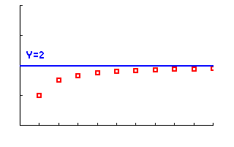
A nondecreasing sequence that
is bounded above by 2.

NOTE: Sequence $a_{n}=n^{2}$ above marches off to infinity. However, sequence $b_{n}=1-\frac{1}{n}$ above is bounded above by 1 and has limit 1.

Bounded Sequences:
1. A sequence $\left\{a_{n}\right\}$ is bounded above if there is a real number M such that $a_{n}≤M$ for all $n$. The number M is called an upper bound of the sequence.
2. A sequence $\left\{a_{n}\right\}$ is bounded below if there is a real number N such that $a_{n}≥N$ for all $n$. The number N is called a lower bound of the sequence.
3. A sequence $\left\{a_{n}\right\}$ is bounded if it is bounded above and bounded below.

Monotonic Sequence Theorem: Every bounded, monotonic sequence is convergent.

NOTE: In the theorem above it is not necessary that the sequence $\left\{a_{n}\right\}$ be monotonic initially, only that they be monotonic from some point on—that is, for $n≥K$. In fact, the convergence or divergence of a sequence does not depend on the character of its initial terms but rather on what is true for large n.

Example: Use the Monotonic Sequence Theorem to show that
$$a_{n}=\left(1-\frac{1}{4}\right)\left(1-\frac{1}{9}\right)⋯\left(1-\frac{1}{n^{2}}\right), n≥2$$
converges.

