**Study Guide for the Final Examination**

MATH 1111

1. Solve the equation .

2. Solve the equation .

3. Solve the inequality x2 + 4x ≥ -3.

4. Solve the inequality .

5. Solve the inequality .

6. Determine if the following are symmetric with respect to the $x$-axis, $y$-axis, or origin.

(a) (b)

(c) (d)

(e)

7. Find the - and -intercepts of .

8. Find an equation for the line containing the points and .

9. Find the center and radius of the circle .

10. Find an equation of the line which is perpendicular to $x –7y=3$ and contains the point .

11. If , find .

12. Determine whether the point $\left(2, 5\right)$ is on the graph of f(x) = 3x2 − 6x + 5.

13. Find the domain of .

14. Determine which of the following are polynomials. For those that are, state the degree. For those that are not, state why.

(a) 

(b) 

(c) g(x) = 3x4 + 3x2 + 1

(d) 

(e) g(x) = -4x + 1

(f) g(x) = 4

15. Assume that the graphs in the figure below are those of polynomials. What is the *least* possible degree of each polynomial?

(a) (b) (c) (d) (e)

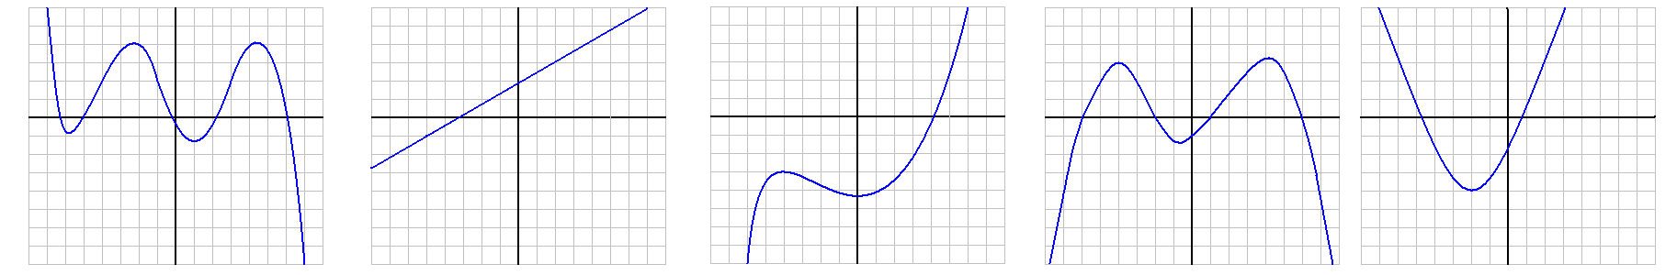

16. Use the Factor Theorem to determine if the following are factors of

$x^{3}+4x^{2}+x-6$.

(a) (b)

(c) (d)   
(e) (f)

17. Factor f(x) = 2x3 + x2 – 5x + 2 completely.

18. Solve for x: x6 + 7x3 – 8 = 0.

19. Solve the following system of equations.

20. Solve the following system of equations.

21. In chemistry, the acid potential of aqueous solutions is measured in terms of the pH scale. Since tremendous swings in hydrogen ion concentration occur in water when acids or bases are mixed with water, pH uses a logarithmic scale. The pH of a substance is defined as , where  is the hydrogen ion concentration, measured in moles per liter. If garden soil has a pH value of 6.5, find its hydrogen ion concentration value. Use scientific notation with values rounded to the nearest tenth.

22. Simplify the following.

(a) (b)

23. If , then

(a) express it in terms of a logarithm base 3,

(b) express it in terms of common logarithms,

(c) express it in terms of natural logarithms, and

(d) solve the equation.

24. Compute $f∘g$ for the following functions.

(a) (b)

25. (a) Write the following as a single logarithm.

$$\log_{3}{(2x^{2}-x-1)}-\log_{3}\left(x-1\right)$$

(b) Use logarithm rules to express the following as the sum and/or difference of logarithms. Write powers as factors.



26. Solve algebraically:

27. Solve for :

28. If $1,200 is invested for 9 years at an annual percentage rate (APR) of 2.3%, determine the amount of money when it is compounded

(a) semiannually (b) monthly

(c) daily (d) continuously

29. Simplify. Use only positive exponents in your solution.



**Answers**

1. −3 2.

3. 4. or (-1, 4)

5.

6. (a) -axis (b) $y$-axis

(c) $x$-axis, $y$-axis, origin (d) origin

(e) none

7. -intercept: ; -intercept:

8. or y = 4x – 5

9. Center: ; radius: 6 10. or y = -7x + 40

11. −30 12. Yes, since . 13.

14. (a) No, because there as an $x$ under a radical.

(b) Yes, degree 7. (c) Yes, degree 4.

(d) No, because there is an $x$ in the denominator of a fraction.

(e) Yes, degree 1 (linear) (f) Yes, degree 0

15. (a) degree 5 (b) degree 1 (c) degree 3

(d) degree 4 (e) degree 2

16. (a) No (b) No (c) Yes

(d) Yes (e) No (f) Yes

17. g(x)=(x – 1)(x + 2)(2x – 1)

18. x = -2 or x = 1 19. {(-2, 3)} 20. {(2, 1, -1)}

21. 3.2∙10-7 mol/L 22. (a) (b)

23. (a) (b)

(c) (d)

24. (a)

(b)

25. (a) (b)

26. 27.

28. (a) $1,474.24 (b) $1,475.69

(c) $1,475.97 (d) $1,475.98

29. 