Summary for Section 7.3 ($σ$ is known)

CLT for $\overline{x}$ | C.I. = Confidence Interval | Sample size n
n > 30  Or  The population distribution is bell shaped to start with.  The C.L.T. for $\overline{x}$ says:  The sampling distribution for $\overline{x}$ will be bell shaped with:  $μ\left(\overline{x}\right)$ = $μ$  $σ\left(\overline{x}\right)$ = $\frac{σ}{\sqrt{n}}$  $σ\left(\overline{x}\right)$ = the standard deviation of $\overline{x}$ s.  = the standard error of the mean. | $μ$ = Best Estimate $± Error$  Best Estimate = $\overline{x}$  Error = $Z_{α/2}\frac{σ}{\sqrt{n}}$  So $μ=$ $\overline{X}$ $±$ $Z_{α/2}\frac{σ}{\sqrt{n}}$  Example:  $μ$ = 180 $±$ 5  Best Estimate = $\overline{X}$ = 180  Error = 5  C.I. is $μ ∈\left[175,185\right]$  C.I. is $μ ∈$ [L , U] | You need a C.I. with high confidence (which means a specified level of confidence) and a small error (which means a specified E).  So the question boils down to:  How big the sample size should be to guarantee a high specified confidence and a small specified error.  n = ${\left(\frac{Z_{α/2} σ}{E}\right)}^{2}$  When computing the sample size n, you always round up.

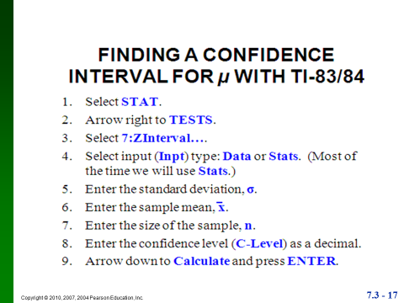

Summary for Section 7.3 ($σ$ is unknown)

CLT for $\overline{x}$ | C.I. = Confidence Interval | Sample size n
n > 30  Or  The population distribution is bell shaped to start with.  The C.L.T. for $\overline{x}$ says:  The sampling distribution for $\overline{x}$ will be bell shaped with:  $μ\left(\overline{x}\right)$ = $μ$  $σ\left(\overline{x}\right)$ = $\frac{s}{\sqrt{n}}$  $σ\left(\overline{x}\right)$ = the standard deviation of $\overline{x}$ s.  = the standard error of the mean.  S = Standard deviation of the sample.  $\overline{x}$ = Average of the sample. | $μ$ = Best Estimate $± Error$  Best Estimate = $\overline{x}$  Error = $t_{α/2}\frac{s}{\sqrt{n}}$  So $μ=$ $\overline{X}$ $±$ $t_{α/2}\frac{s}{\sqrt{n}}$  t stands for the student t distribution in reference to the Statistician William Sealy Gosset.  The $t_{α/2}$ can be found from the TI or read from a table.  Example:  $μ$ = 180 $±$ 5  Best Estimate = $\overline{X}$ = 180  Error = 5  C.I. is $μ ∈\left[175,185\right]$  C.I. is $μ ∈$ [L , U] | You will not have problems to compute the sample size needed when  $σ$ is unknown
