USING LOGRARITHMIC GRAPH PAPER
Logarithmic graph paper is seldom seen by students in elementary courses. There seems to be a general impression that (1) it is too difficult to deal with, or (2) students "can pick it up" without instructions. Niether is true, in my opinion.
In the days of slide rules, students had (or ought to have had) intimate familiarity with logrithms and logarithmic scales, for every slide rule had at least two such scales. Nowadays many of these gory details are hidden in the innards of an electronic calculator or computer, a "black box" that grinds out numbers, whether or not those numbers have any significance.
Graphs with logarithmic scales are found in research papers and textbooks. One example is the usual graph of the electromagnetic spectrum. If students are to interpret such graphs intelligently, they need to directly experience the process of making one.
All sorts of computer graphing software is available. The most used software is designed for the needs of business, not science. Many such software packages simply cannot do the things necessary for dealing with the needs of physics.
7.8 LOGARITHMIC GRAPH PAPER
Logarithmic graph papers are available in many types. They simplify the process of linearizing exponential and power relations and determining the constants in their equation.
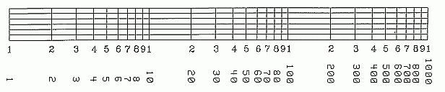
Fig. 7.8. Relabeling a logarithmic scale.

