STRATEGY FOR GRAPHING TRIGONOMETRIC FUNCTIONS
USING
MAPPING & SUPERPOSITION

Dr. Marwan Zabdawi
Gordon State College
mzabdawi@gordonstate.edu
81 Chad Court
McDonough, GA 30253

Abstract
Virtually all books in Pre-Calc. do not give the student an outline on how to graph trigonometric functions with amplitudes, non-standard periods, phase shifts and vertical translation. Instead, examples are given for specific scenarios by fixing the scale and changing the window/graph. Hence, the student is left bewildered in a mathematical maze trying to find a way out. This paper uses the concepts of mapping and superposition to resolve any combination of scenarios and even all scenarios combined. Mapping and superposition is done by fixing the window/graph and changing the scale. Two examples will be tabulated and graphed with a strategy where the student can go through it mechanically and without a hitch. The TI-84 Plus will be used for verification of two examples in the form:
$y=aSecb\left(x±c\right)±d$ and $y=aTanb\left(x±c\right)±d$
A bullet format outline follows with two examples to demonstrate the procedure.

Procedure:
- For graphing functions in the format:
$y=aSecb\left(x±c\right)±d$, we need to graph $y=aCosb\left(x±c\right)±d$
- Amplitude = $\left|a\right|$
- Period = $\frac{2π}{b}$
- Phase Shift = $If\left(\begin{matrix}+ c & Graph is shifted c units to the left \\ - c & Graph is shifted c units to the right\end{matrix}\right)$
- Vertical Translation = $If\left(\begin{matrix}+ d & Graph is moved d units up \\ - d & Graph is moved d units down\end{matrix}\right)$

- Alignment/Mapping is defined as finding the x-values for which the new signal has the same y-values as the original classical signal before horizontal shifting, amplifications and/or vertical translation.
- Superposition is defined as super-imposing the new graph on the fixed window of the original classical signal by simply changing the scale.
It sounds complicated, but the following two examples will illustrate the idea, and we’ll use the acronym ASAUD which stands for (Aligned, Shifted, Amplified, UP or Down).
Let us graph $y=-2Sec2\left(x+\frac{π}{2}\right)+1, ………eq.(1)$ hence, we need to graph
$y=-2Cos2\left(x+\frac{π}{2}\right)+1, ………eq.(2)$
- Amplitude = $\left|-2\right|=2$
- Period = $\frac{2π}{2}=π$
- Phase Shift = $\frac{π}{2} units$ to the left (subtract)
- Vertical Translation = 1 unit up.
The original classical signal which is the building block for this graph is y = Cos(x)

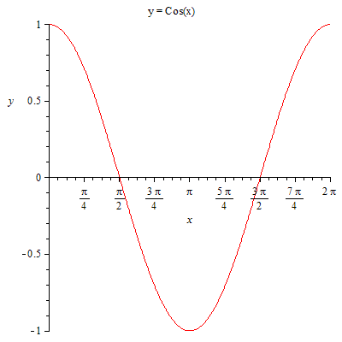 Fig. (1)

The following table with the use of the acronym ASAUD will transform the graph given in Fig. (1) to the graph of eq. (2).
For the alignment, we divide the new period $π into four cycles$to align it with the four cycles of the original classical signal y = Cos(x).

x of  y= Cos(x) | Aligns with x | Shifted to x  $$-\frac{π}{2}$$ | Y values of y= Cos(x) | Y Amplified by -2 | Y Moved up by 1
0 | 0 | $$-\frac{π}{2}$$ | 1 | -2 | -1
$$\frac{π}{2}$$ | $$\frac{π}{4}$$ | $$-\frac{π}{4}$$ | 0 | 0 | 1
$$π$$ | $$\frac{π}{2}$$ | 0 | -1 | 2 | 3
$$\frac{3π}{2}$$ | $$\frac{3π}{4}$$ | $$\frac{π}{4}$$ | 0 | 0 | 1
2$π$ | $$π$$ | $$\frac{π}{2}$$ | 1 | -2 | -1

We now take the last x and y values from the table above to plot eq. (2). Because of the linearity of the transformations, the amplifications and the vertical translations were done solely on the original signal y= Cos(x) regardless of the horizontal shifting. The minus
sign in the amplification indicates that the signal had been flipped upside down as: 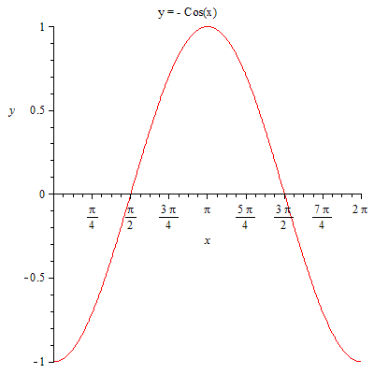

Now by fixing the window and changing the scale, we simply transform the graph of y=Cos(x) to the graph of $y=-2Cos2\left(x+\frac{π}{2}\right)+1$

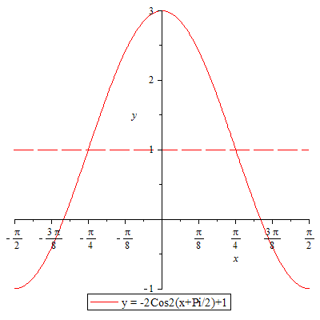

Bearing in mind that the axes are inserted after the graph is drawn with its tick marks taken from the last x and y values from the table above. Keeping track of the wanted graph of eq. (1) and recalling that $Secx\left(x\right)=\frac{1}{Cos(x)}$ , the position of the asymptote of the secant function is the same as the position of the zero value of the cosine function before the vertical translation (where the dashed line intersected the graph), and hence the final graph of eq.(1) is:

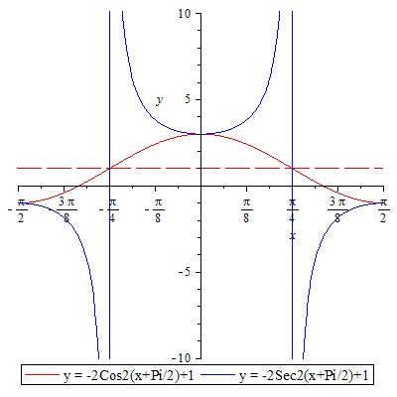

Procedure:
- For graphing functions in the format:
$$y=aTanb\left(x±c\right)±d$$
- Amplitude = Infinity
- Period = $\frac{π}{b}$
- Phase Shift = $If\left(\begin{matrix}+ c & Graph is shifted c units to the left \\ - c & Graph is shifted c units to the right\end{matrix}\right)$
- Vertical Translation = $If\left(\begin{matrix}+ d & Graph is moved d units up \\ - d & Graph is moved d units down\end{matrix}\right)$
Let us graph$y=-2Tan2\left(x-\frac{π}{2}\right)-1, ………eq.(3)$
- Amplitude = Infinity
- Period = $\frac{π}{2}$
- Phase Shift = $\frac{π}{2}$ to the right (Add)
- Vertical Translation = 1 unit down
The original classical signal which is the building block for this graph is y = Tan(x)

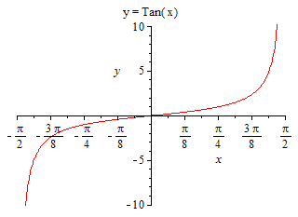Fig. (2)

The following table with the use of the acronym ASAUD will transform the graph given in Fig. (2) to the graph of eq. (3).
For the alignment, we divide the new period $\frac{π}{2} into two cycles$to align it with the two cycles of the original classical signal y = Tan(x).

x of  y= Tan(x) | Aligns with x | Shifted to x  $$+\frac{π}{2}$$ | Y values of y= Tan(x) | Y Amplified by -2 | Y Moved down by 1
$$-\frac{π}{2}$$ | $$-\frac{π}{4}$$ | $$\frac{π}{4}$$ | -$∞$ | $$∞$$ | $$∞$$
0 | $$0$$ | $$\frac{π}{2}$$ | 0 | 0 | -1
$$\frac{π}{2}$$ | $$\frac{π}{4}$$ | $$\frac{3π}{4}$$ | $$∞$$ | $$-∞$$ | $$-∞$$

We now take the last x and y values from the table above to plot eq. (3). Again, because of the linearity of the transformations, the amplifications and the vertical translations were done solely on the original signal y= Tan(x) regardless of the horizontal shifting. The minus sign in the amplification indicates that the signal had been flipped upside down as:
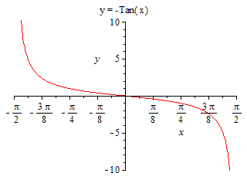
Now by fixing the window and changing the scale, we simply transform the graph of y=Tan(x) to the graph of $y=-2Tan2\left(x-\frac{π}{2}\right)-1$
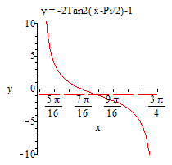
Bearing in mind that the axes are inserted after the graph is drawn with its tick marks taken from the last x and y values from the table above.

The same procedure can be applied to graphs in the format:
$y=aCscb\left(x±c\right)±d$ and $y=aCotb\left(x±c\right)±d$

