STRATEGY FOR GRAPHING POLYNOMIALS & RATIONAL FUNCTIONS

Dr. Marwan Zabdawi
Gordon College
mzabdawi@gdn.edu
81 Chad Court
McDonough, GA 30253

Abstract

Almost all books in College Algebra, Pre-Calc. and Calculus, do not give the student a specific outline on how to graph polynomials and rational functions. Instead, domains, intercepts, limits, continuity and asymptotes are detailed separately, and the student is left bewildered in a mathematical maze trying to find a way out. This paper uses all of the individual graphing ingredients and weaves them in a step by step procedure, where the student can go through it mechanically and without a hitch.

An interactive (bullet format) outline follows with two examples to demonstrate the procedure.

Procedure:
- State the domain.
- Find the Y-intercepts (x=0), and the X-Intercepts (y=0) the easy one in particular. You can use the synthetic division to find the rational zeros for the given polynomial function. Basically, if f(c)=0, then (x-c) is a factor of f(x).
- For rational functions ONLY, find the asymptotes.
- Perform the sign analysis.
- Graph the function.

Now if we elaborate on step (3) for rational functions, we have: vertical asymptotes, horizontal asymptotes, and oblique/slant asymptotes.

Asymptotes For Rational Functions
- Vertical Asymptotes:
Whatever makes the denominator zero is your vertical asymptote, as long as you do not have 0/0. Remember that 0/0 means that you have a hole in the graph.

- Horizontal & Slant asymptotes:
Are the limits of the rational function as $x→±∞$

Horizontal & Slant asymptotes
Consider the following rational function:
$$f\left(x\right)=\frac{a_{n}x^{n}+a_{n-1}x^{n-1}+…+a_{1}x+a_{0}}{b_{m}x^{m}+b_{m-1}x^{m-1}+…+b_{1}x+b_{0}}$$

- If the power of the numerator is the same as the power of the denominator (n=m), then the horizontal asymptote is y = the ratio of the leading coefficients of x, $y=\frac{a_{n}}{b_{m}}$
- If the power of the numerator is less than the power of the denominator (n<m), then the horizontal asymptote is y=0.
- If the power of the numerator is greater than the power of the denominator by one degree (n=m+1), then the slant asymptote is y= the quotient of the division.
Here the synthetic division can prove helpful when warranted.
Notice that for rational functions, it should be very obvious that you cannot have horizontal and slant asymptotes at the same time.

Using the Outlined Procedure Graph:

$$f\left(x\right)=(x-1)(x+2)(x-3)$$
- Domain: $x∈\left(-∞,∞\right)$
- Y-Intercept: x=0 $→\left(0,6\right)$
- X-Intercepts: y=0$→\left(1,0\right),\left(-2,0\right),\left(3,0\right)$
- Sign Analysis:
-$∞$ -2 1 3 +$∞$
$$x$$
$$f(x)$$ | $$-$$ | + | $$-$$ | +

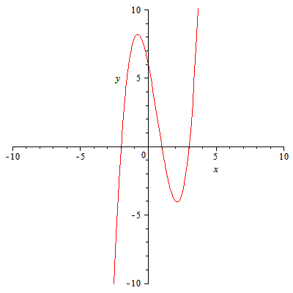
Fig. (1)
Using the Outlined Procedure Graph:

$$f\left(x\right)=\frac{2(x^{2}-1)}{\left(x+3\right)\left(x-2\right)}$$

- Domain: $xϵ\left(-∞,-3\right)∪\left(-3,2\right)∪\left(2,∞\right)$
- Y-Intercept: x=0$→\left(0,\frac{1}{3}\right)$
- X-Intercepts: y=0$→\left(-1,0\right), \left(1,0\right)$
- Asymptotes:
$$x→±∞, y→2; y=2 is a Horizonatl Asymptote$$

$$x→-3, y→±∞; x=-3 is a Vertical Asymptote$$

$$x→2, y→±∞; x=2 is a Vertical Asymptote$$

- Sign Analysis:

$-∞$ $-3$ $-1$ 1 2 $∞$
$$x$$
$$f(x)$$ | $$+$$ | $$-$$ | $$+$$ | $$-$$ | $$+$$

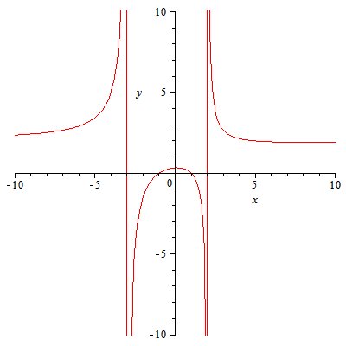
Fig.(2)

