Math 1501
Derivative of f(x) = Sinx

Show that $\underset{x→0}{\text{lim}}\frac{\text{sin}x}{x}=1$

- Numerically
- Geometrically
- Algebraically

a) Numerically

($x$ is in radians)

$x$ $\frac{\text{sin}x}{x}$

0.1 0.998
0.01 1.00
0.001 1.000
--------------------------------
-0.1 0.998
-0.01 1.000
-0.001 1.000

$∴$ $\underset{x→0}{\text{lim}}\frac{\text{sin}x}{x}=1$

b) Geometrically
The graph of $\frac{\text{sin}x}{x}$ is

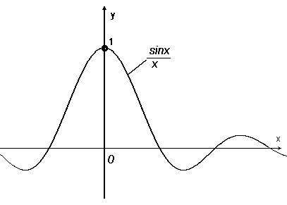

$∴$ $\underset{x→0}{\text{lim}}\frac{\text{sin}x}{x}=1$

c) Algebraically

Area of $Δ\text{OAB}$< Area of sector OAB <$Δ\text{OCB}$

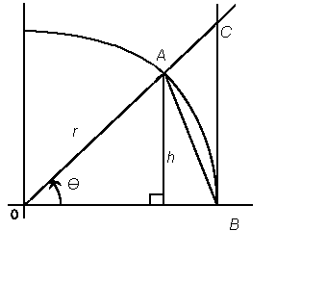
$⇒$ $\frac{\text{hOB}}{2}<\frac{r^{2}θ}{2}<\frac{\text{OB}⋅\text{BC}}{2}$

$r=1$ on the unit circle

$\text{sin}θ=\frac{h}{r}=\frac{h}{1}=h$; $\text{OB}=\text{OA}=r=1$

$⇒$ $\frac{\text{sin}θ}{2}<\frac{θ}{2}<\frac{\text{BC}}{2}$; $\text{OB}=1$

$\begin{aligned}\text{tan}θ=\frac{\text{BC}}{\text{OB}}=\frac{\text{BC}}{1}=\text{BC} \\ \end{aligned}$
$⇒$ $\frac{\text{sin}θ}{2}<\frac{θ}{2}<\frac{\text{tan}θ}{2}$

$\text{sin}θ<θ<\text{tan}θ$

$1<\frac{θ}{\text{sin}θ}<\frac{1}{\text{cos}θ}$

$$1>\frac{\text{sin}θ}{θ}>\text{cos}θ$$

$⇒$ $\text{cos}θ<\frac{\text{sin}θ}{θ}<1$
$\underset{θ→0}{\text{lim}}\text{cos}θ=1$, $\underset{θ→0}{\text{lim}}1=1$
$$\underset{θ→0}{\text{lim}}\frac{\text{sin}θ}{θ}=1$$
By the Squeeze Theorem $⇒$ (1)

Show that: $\underset{h→0}{\text{lim}}\frac{\text{cos}(h)−1}{h}=0$
$\underset{h→0}{\text{lim}}\frac{\text{cos}(h)−1}{h}=\underset{h→0}{\text{lim}}\frac{(\text{cos}(h)−1)(\text{cos}(h)+1)}{h(\text{cos}(h)+1)}$
$=\underset{h→0}{\text{lim}}\frac{({\text{cos}}^{2}h−1)}{h(\text{cos}(h)+1)}$
But ${\text{cos}}^{2}h−1=−{\text{sin}}^{2}h$, because ${\text{cos}}^{2}h+{\text{sin}}^{2}h=1$
$⇒$ $\underset{h→0}{\text{lim}}\frac{\text{cos}(h)−1}{h}=\underset{h→0}{\text{lim}}\frac{−{\text{sin}}^{2}h}{h(\text{cos}(h)+1)}$
=$\left(\underset{h→0}{\text{lim}}(−\text{sin}(h))\right)⋅\left(\underset{h→0}{\text{lim}}\frac{\text{sin}(h)}{h}\right)⋅\left(\underset{h→0}{\text{lim}}\frac{1}{\text{cos}(h)+1}\right)$
=$0⋅1⋅\frac{1}{2}=0$ QED
$$\underset{h→0}{\text{lim}}\frac{\text{cos}(h)−1}{h}=0$$
(2)

Show using Fermat’s Definition of Derivatives that:
$$\frac{d\text{sin}x}{\text{dx}}=\text{cos}x$$
Let $f(x)=\text{sin}x$
$\frac{\text{df}}{\text{dx}}=\underset{h→0}{\text{lim}}\frac{f(x+h)−f(x)}{h}$
$=\underset{h→0}{\text{lim}}\frac{\text{sin}(x+h)−\text{sin}x}{h}$
$=\underset{h→0}{\text{lim}}\frac{\text{sin}x\text{cos}(h)+\text{cos}x\text{sin}(h)−\text{sin}x}{h}$
$=\underset{h→0}{\text{lim}}\frac{\text{sin}x(\text{cos}(h)−1)+\text{cos}x\text{sin}(h)}{h}$
$=\underset{h→0}{\text{lim}}\frac{\text{sin}x(\text{cos}(h)−1)}{h}+\underset{h→0}{\text{lim}}\frac{\text{cos}x\text{sin}(h)}{h}$
$=\text{sin}x⋅\underset{h→0}{\text{lim}}\frac{(\text{cos}(h)−1)}{h}+\text{cos}x⋅\underset{h→0}{\text{lim}}\frac{\text{sin}(h)}{h}$
But from Eq. (1) we have $\underset{h→0}{\text{lim}}\frac{\text{sin}(h)}{h}=1$
And from Eq. (2) we have $\underset{h→0}{\text{lim}}\frac{(\text{cos}(h)−1)}{h}=0$
$$\frac{\text{df}}{\text{dx}}=\text{sin}x⋅0+\text{cos}x⋅1=\text{cos}x$$
For$f(x)=\text{sin}x$,$f^{'}(x)=\frac{\text{df}}{\text{dx}}=\text{cos}x$ QED

