Research Paper

The Assignment:
Drawing upon scholarly research, compose an original scholarly interpretation of a topic that in some way connects to Tim O’Brien’s The Things They Carried. Pick something you like or wish to explore and the process will be easier. I will be happy to explore topics with you if needed! The trick is to pick something you think you can write 1350 words on, and be able to find 4-5 secondary sources .

You should have already thought of a thesis, since it is due before this.
You should have already found sources since it is due before this.

A research paper must be shaped like a long essay with multiple paragraphs in the body. However, the body paragraphs are filled with cited examples from sources to back up/support your ideas, NOT just your own opinions and ideas. The organization, style, and position of the thesis and the way it is supported is YOURS, but the data/information you use, like a lawyer, is EVIDENCE from credible secondary sources, not blogs, not quote cites, not essay forums, not pay-for-it cites and not Wikipedia! Remember the MEAL plan – start each paragraph with the Main idea/topic sentence, then give an Example sentence that explains or shows the main idea, then explain why the example is important and the purpose for mentioning it (this is the Analysis sentence), and finally, Linking sentence that concludes the paragraph and connects the main idea mentioned in sentence one to wherever you are going in the next paragraph.

When you use an example from a secondary source, don’t forget to cite it in parenthesis after the quote part; don’t forget to avoid HANGING QUOTES that are just an entire sentence of some quoted source WITHOUT having some of your own words in that sentence; don’t forget a good citation needs AUTHOR and PAGE NUMBER. If you don’t know the author, use the title of the secondary source, but keep in mind, sources without authors are probably not good sources. A good source needs:
- Author
- Copyright date
- Title
- Page number

DO NOT FALL INTO THE SUMMARY/PLOT TRAP! THE CUT-AND-PASTE TRAP! You need to interpret, explain, focus on how and why and because in YOUR OWN WORDS!

Your essay must prove your thesis through an appropriate use of summaries, quotes, and paraphrases from both your primary and secondary sources. Papers that do not contain textual evidence in the form of summaries, quotes and paraphrases will not receive a passing grade. Your quotes and paraphrases must be cited in MLA parenthetical style.

Your essay must begin with a fully-developed introduction that includes a hook, some background information, and an original thesis about your work of literature.

Your essay must end with a fully developed conclusion.

Your essay must contain a final Works Cited page written in MLA style.

You will need a catchy title to draw the reader in. “My Research Paper” or “Essay on Brilliant Author” or “Examining Brilliant Story” are all going to lead to some lost points. (This seems a shame when it only takes a few minutes to think up an original title!)

Avoid second person (“you”) which can so easily be found by control + F (the search key).

Well-written papers that use scholarly sources exclusively will receive grades of A or B; bibliographies that rely more heavily on popular, non-scholarly media such as encyclopedias, websites and media reviews will probably receive grades of C and below.

Do not wait until the last minute. Begin early. Did you read that?

Stop zoning out! This is worth a large percentage of your final grade!

But Mr. Silverman, this is so hard! “Yes, yes it is.”

For further help, see: http://owl.english.purdue.edu/owl/resource/658/3/ (for help choosing a topic, organizing, and so forth).

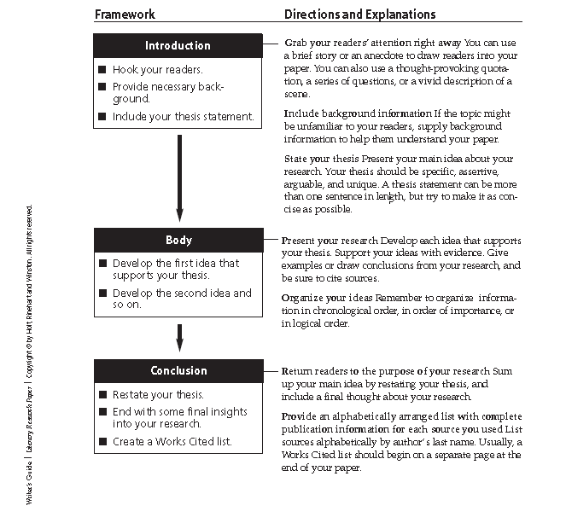

Format requirements:

Minimum length 1350 words; maximum length 1999 words.

Format: typed, double-spaced, with 1” margins, 12 pt. Times font or something similar, left justified. Do NOT hit enter at the end of every line – this will make your spell checker useless!

Reminder: parenthetical citations and Works Cited page must follow MLA style.

Include the following in the upper right hand side of the first page: your name; the title of your paper; the number of words in your paper; and your class time (8am or 930am).

Number each page, preferably like this: “Silverman 2”, but if you don’t know how, no problem. Oh, and use your own last name!

Proofread carefully. Use your spell check function and your grammar check function on your word processor. The word count should be on the bottom of the Word screen or you can click on “file” if you have an older version of the software.

