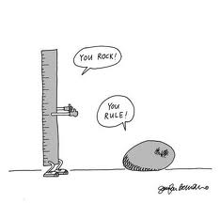

Ch 2-3 & 5-6 Double Point Quiz
For this quiz, you can use the following resources: 1) your book, 2) the Internet.
Do not “use”, “ask”, or “borrow” from another student. This is your work.
- Describe the character of Martha.
- Is Martha a flat/2-dimensional character or a round/3-dimensional character?
- How did Cross get the new Martha photo?
- What do the pictures symbolize?
- What is the symbolism of the checkers and how does it apply to this novel?
- Explain the similes:
- “you could end up like popcorn”
- “boredom dripping inside you like a leaky faucet”
- Explain the theme as discussed on page 34-35 (the page that begins “There were actually tears in the old guy’s eyes.”).
- What was the crazy part about Jensen’s fight?
- What was the outcome of the Jensen-Strunk pact?
- What is a wheelchair wound?
- Compare & contrast chapters 5-6 to the Vietnam Conflict. This could be a simple list or VINN diagram.
- What did you like most or least about the first 6 chapters? Explain why (use an example).
- If you could change one thing about anything in this book so far, what would it be and why?

