____________________________________________________________________________________
(Questions are below)
Every introduction should begin with a hook or attention grabber? What is that? Basically, it is one to three sentences that will pull your reader into your topic and catch their interest or ‘hook’ them. Then most writers will use a transition and begin the actual introduction part. Below are the different hooks and examples of each. (Hopefully this is a review from 1101!)
Types of Attention Grabbers or Hooks (a few sentences at very beginning of paper):
- pose a question (can be trite and boring so has to be really, really different or perhaps shocking
- illustration, anecdote, or small narrative/personal example to set the scene
- Imagine a 10-year old boy named Luka alone at home. Mom is on her way home from work.
- surprising fact or idea
- According to a U. S. Census bureau report, 24 million children under the age of 12 are home alone before or after school.
- In any given college classroom, the odds of a student being diagnosed with HIV is one in every four.
- a direct quotation that is interesting
- contradiction of what most people actually believe
- Growing children do not need to be supervised. Adult guidance can hinder freedom; it can limit choices.
- Since the middle of the 1940s, the female Cannabis sativa plant, commonly known as marijuana, has been classified by the United States government as a Schedule I drug. This classification recognizes marijuana as a dangerous narcotic, similar in potency to heroin and possessing no redeeming medicinal qualities. However, research in the last few years has brought many new discoveries to treat many different illnesses, including glaucoma, cancer, asthma, and phantom limb pain suffered by paraplegics. (not a definition thesis)
- current event heard on radio, news, television, or the internet to lead into your thesis
- This morning’s newspapers reported a man who had shot his twenty-three year old girlfriend and her nine-month old child because he believed his girlfriend had transmitted AIDS to him. Though this incident seems bizarre and sinful, many people fear AIDS because of the consequences of the disease, the misinformation concerning the disease, and the increasing number of cases of the disease. (not a definition thesis)
__________________________________________________________________________________
Add a different hook for each thesis sentence listed below:
- Helping a son or daughter plan a wedding can create family unity, leave pleasant memories, and sometimes create unexpected expenses.
- Smoking is detrimental because it costs money, creates pollution, and results in medical problems.
- Terrorism in the 21st Century has become a major issue since the incidents in new York, Madrid, and London.
______________________________________________________________________________
- For the paragraph below, decide what type of hook is being used.

- For the paragraph below, what is not an addiction according to the author?

- For the introductory paragraph below, what is the thesis?
Television Addiction by Marie Winn
The word “addiction” is often used loosely and wryly in conversation. People will refer to themselves as “mystery book addicts” or “cookie addicts.” E. B. White writes of his annual surge of interest in gardening. : We are hooked and are making an attempt to kick the habit.” Yet nobody really believes that reading mysteries or ordering seeds by catalogue is serious enough to be compared to an addiction to heroin or alcohol. The word “addiction” is here used jokingly to denote a tendency to overindulge in some pleasurable activity. While people often refer to being “hooked on TV,” it does not fall into the light-hearted category of a pleasurable hobby that people pursue with unusual intensity like comic book collecting or knitting circles but the more serious and destructive addiction.
_______________________________________________________________________________
- Directions: Below is a paragraph taken from an essay. Put a star/underline the evidence/examples. How many are there?: _____
Despite its brashness and humor, the long-running television sitcom Roseanne presents realistically many of the pressures confronting the American family. Constantly faced with a pile of bills they cannot pay, Dan and Roseanne Connor embody the unrelenting economic struggle of the American family breadwinners. Dan pursues his dream of owning a small business but fails in his attempt to jump start a motorcycle repair shop and ultimately must settle for a job as manager of a city maintenance facility. Meanwhile, to buffer the family's economic woes, Roseanne takes what jobs she can get, including telephone soliciting, waiting tables at a lunch counter, and cleaning up at a beauty parlor. As the economic pressures on the family mount, so do the emotional. Roseanne's having to leave the home and her children in order to supplement the family income yields for her feelings of guilt and anger and results in additional friction between her and Dan. The Connor's home is further immersed in turmoil by the elopement of daughter Becky with her unacceptable boyfriend Mark. If economic and emotional pressures were not enough, the family has to wage the class struggle on a daily basis as well. The issue of their low social status surfaces most clearly with the appearance of a condescending next door neighbor from Chicago who looks down her nose at the community and Roseanne. Ultimately, however, Roseanne and the Connor family succeed in humorously sloughing off the pretension of the neighbor and others they encounter by simply outlasting them and finding strength in their family bonds.

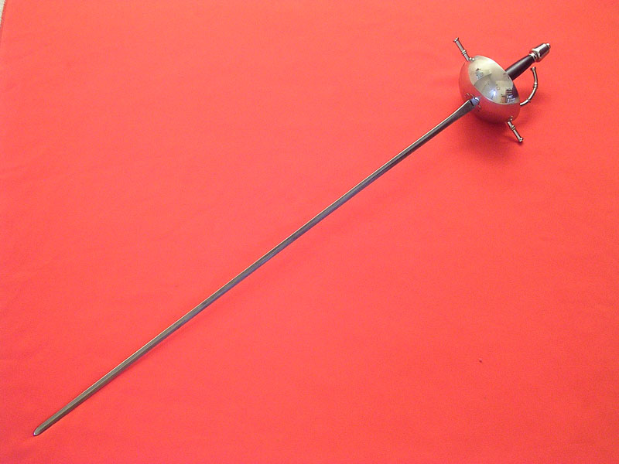
The Schlager by Struthers Burt
The schlager is an immensely long, thin sword, not much wider than a razor and ground to a razor’s sharpness. It is slightly curved, and has a blunt end and basket hilt to protect your hand. When you fight, you stand close together, one arm behind you, your sword arm crooked and above your head, and all the action is with the wrist. The object is to flick pieces of flesh from the scalp and face of your opponent, and you mustn’t give way an inch, or grimace, and, under no circumstances, emit an “ouch!” or its German equivalent. The bouts take place in a hall, or cockpit, designed for the purpose, and there are numerous spectators, most of them members of the groups involved. There is always a young surgeon in attendance whose duty it is to stop the fight if there is too much loss of blood, or between rounds, to sew up long wounds and doctor small ones. He operates in as brutal a manner as possible in order to further indoctrinate the young men in courage, also in order that the scars may heal badly. This, naturally, is good for the young surgeon, too— it teaches him not to be sentimental I his future practice. If you achieve good wounds, you put salt in them and keep them open to make spectacular scars.
- Define schalger.
- What is the purpose of a schlager match? Have you ever seen this or some other type of match that makes the contestants bloody?
- Why put salt in the wounds?
- Do you think this is real? How would you find out if it was real or not?
- What is the tone of this paragraph?
- Add a hook sentence.

