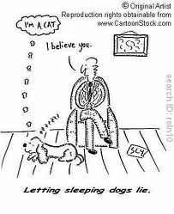
Good stories use facts as examples by focusing on answering the 6 question words (who, what, where, when, why and how) and by explaining using details (adjectives, adverbs, action verbs, metaphors/similes, allusions, quotes of what people actually said or thought, and secondary sources). Make sure your examples and facts name people, places, things, activities, jobs, etc.

Write down three truthful factual statements about yourself and one lie. Try not to make it too obvious like “I am a boy” if you are a boy or “I have hair” if you have hair. Then number your paper from 1 to ________.
- Matthew
- I have been teaching since 1997 but this is my 6th year at Gordon.
- I like to go sky diving whenever I can.
- I once broke into a house by accident and stole a can of spam.
- I am 45 years old and have a thirteen year old daughter named Isabel.

Notice I never say:
My favorite color is blue

