**Active / Passive Verb Forms**

Passive Verbs

Writers too often use passive verbs and passive construction. Count the number of times you use a form of "to be" in your essay. Often, these words should be replaced with more colorful and precise verbs. What action is really taking place? Try using stronger verbs.

|  |  |  |
| --- | --- | --- |
| **Forms of "to be"** | **Other boring verbs** | **Passive construction** |
| is am are was were will be will have been has been had been would have been being to be etc. | exists seems appears represents presents constitutes offers has acts as displays makes exemplifies describes characterizes shows occurs contains | there is there are it is here is   Long veils are worn by brides in formal weddings.  Hillary Clinton is admired by many feminists. |

|  |  |
| --- | --- |
| **Examples:** | **Possible Solutions:** |
| Veils are worn by brides in formal weddings. | Brides in formal weddings wear veils. |
| Betty seems to be an efficient typist. | Betty types efficiently. |
| Crest has been shown to be an effective, decay-preventing dentifrice. | Crest prevents cavities. |
| Something will be done about it by her mother. | Her mother will do something about it. |
| The discussion will be led by Mr. James Clubb. | Mr. James Clubb will lead the discussion. |
| There are many women who never marry. | Many women never marry. |

**Active Form**

In active sentences, the thing doing the action is the subject of the sentence and the thing receiving the action is the object. Most sentences are active.

[Thing doing action] + [verb] + [thing receiving action]

Examples:

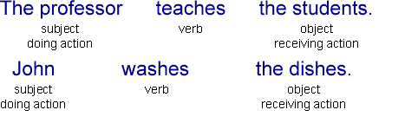

**Passive Form**

In passive sentences, the thing receiving the action is the subject of the sentence and the thing doing the action is optionally included near the end of the sentence. You can use the passive form if you think that the thing receiving the action is more important or should be emphasized. You can also use the passive form if you do not know who is doing the action or if you do not want to mention who is doing the action.

[Thing receiving action] + [be] + [past participle of verb] + [by] + [thing doing action]

Examples:

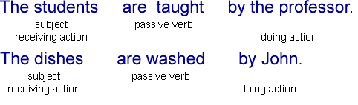

**Difference between Passive Voice and Past Tense**

Many people confuse the **passive voice** with the **past tense**. The most common passive constructions also happen to be past tense (*e.g.* "I've been framed"), but "voice" has to do with **who**, while "tense" has to do with **when**.

|  |  |  |
| --- | --- | --- |
|  | **Active Voice** | **Passive Voice** |
| **Past Tense** | I taught; I learned. | I was (have been) taught [by someone];  It was (has been) learned [by someone]. |
| **Present Tense** | I teach; I learn. | I am [being] taught [by someone];   It is [being] learned [by someone]. |
| **Future Tense** | I will teach; I will learn. | I will be taught [by someone]; It will be learned [by someone]. |

