Questions to ponder for possible topics
for the Twentieth Century Modern Response
Paper#3 (10%):

For this response, we are going to focus on the writers who bring their unique ethnic background into the modern British culture. Pick one and respond to how you felt upon reading it, what you thought about it, what you liked best about it, what you liked least about it, and how does this story/poem reflect a sense of British modernism. Use at least one literary element in your paper (plot, climax, character, setting, theme, tone, symbolism, etc). Use quotes to support your points (see P.E.E. below) and RUBRIC!

Choice 1
Hanif Kureishi “My Son the Fanatic” (story, pg 1202-1209, British-Pakistani)
Movie Trailer: https://www.youtube.com/watch?v=aZlUUFJulM8
Choice 2
Carol Ann Duffy “The Christmas True” (long poem, pg 12-13-1216, British-Scottish)
Movie Trailer: https://www.youtube.com/watch?v=qlYm9P0ujBU
Choice 3
Zadie Smith “The Waiter’s Wife” (story, pg 1238-1248, British-Jamaican, Ch 3 & 4 of The White Teeth)
Theater Trailer: https://www.youtube.com/watch?v=rX74Kjw7IJw

Choice 4
Kiran Desai “The Sermon in the Guava Tree” (story, pg 1227-1236, India-British-American)
Student Essay: (sorry no trailer!!!)

Choice 5 (Must run this option by me via email first)
If you wish to choose a different writer and story who is modern but also an immigrant or from an immigrant family, you might be able to.
Let me know your author, their mixed nationality (British and??) as well as why you want to chose that one. Don’t wait until the last minute! I may not approve but I may - who knows?

**This is a more formal response**
Use at least one of these literary elements to show how the author develops a modern story: theme, setting, symbolism, or tone.
If you summarize the plot then use the plot terms:
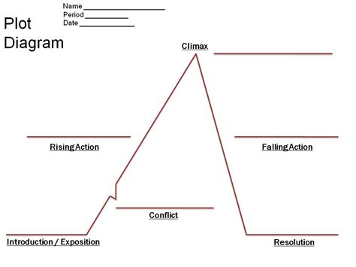

Go beyond the response paper as the first 2 papers were more opinion. Now you should be trying to follow the P.E.E. format which basically is this:
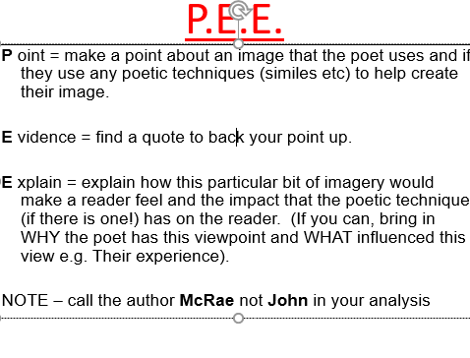
If you sue secondary source, don’t forget to include: quotation marks, parenthetical info which is (author page #), and Work Cited in MLA.
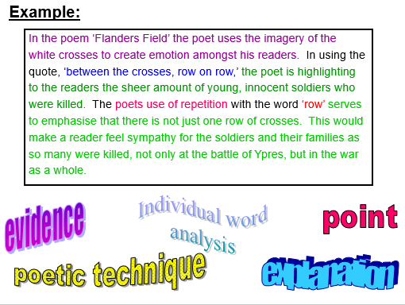

Rubric Checklist for Reader Response 3 (2.5 to 3.5 pages)

Name & Heading & Title that does more than mention name of story/author 7pts
Grammar (avoid fragments, run-on, apostrophe errors, spelling, verb tense) 15pts
Topic Sentences (avoid facts, quotes, or questions & think MEAL) 10pts
1 Lit Element & Focus on examples and quotes (think: how, why, and because):
theme, setting, symbolism, or tone 20pts
MLA properly cited & followed for quotes, citations, and titles 15pts
Transitions 5pts
Introduction & thesis statement that maps out rest of paper 10pts
Plot summary paragraph (exposition, conflict, climax, and resolution) 10pts
Conclusion (this could be spot to include your opinion about story) 5pts
Purpose shown & creativity 5pts
Following Directions & Page Count (min 2.5 pgs) & Exploring assigned topics -15pts
Failure to Turn it in to Turnitin.com -15pts
LATENESS: Due Friday by 6pm -10pts/day

