Dead Fish Handshakes are a huge pet peeve of mine. You offer your hand in greeting and the other person returns a grip that is downright soggy, their hand flopping in yours like a lifeless cod. It’s not a huge offense in the grand scheme of things, but it also seems like such an easy thing to avoid. Floppy, cold, lifeless introductions are equally uninteresting. Nobody wants to keep reading after those “dead fish” beginnings.
Every introduction should begin with a hook or attention grabber! What is that? Basically, it is one to three sentences that will pull your reader into your topic and catch their interest or ‘hook’ them. Then most writers will use a transition and begin the actual introduction part. Some strategies include: dialogue, action, something unexpected, a contrast, a detailed description, or humor. Avoid question hooks because they are boring and the most common.
Below are the different hooks and examples of each. (Hopefully this is a review from 1101!)
- What is a dead-fish beginning?
- Read the 9 types of hooks below. Which are the 2 least interesting and least effective? How do you know?
- Read the 9 types of hooks below. Which one do you think the teacher likes the best? How do you know?
- Read the 9 types of hooks below. Which is the strongest in your opinion? Why?
- Notice how 9a and 2e are the same topic. Come up with a topic as if you had to write an essay and then create two different hooks for the same topic. If you need a topic, you can use one of these but you don’t have to: A) Video games hurt students because they decrease individual’s attention span and damage eye sight. B) School should increase the length of recess in each school day because physical activity helps our brain work more effectively. C) The problems associated with young people and texting have become very harmful on a social and physical level, even fatal.
- What type of hook is this one?
Before efficient extraction methods developed in the late 1800s, aluminum was very difficult to mine. As a result, pure aluminum was more valuable than gold. Napoleon gave banquets where the most honored guests were given aluminum utensils, while the others made do with gold.
- What type of hook is this one?
The Merchant of Venice, one of Shakespeare’s most famous comedic plays, doesn’t seem very funny. Anti-Semitism, discrimination, and revenge aren’t a laughing matter.
- What type of hook is this one?
It was a snow-packed and traffic-jammed Saturday when my Mom and I drove down to Whispering Pines Nursing Home. Since I was still young, I did not quite understand where we were going but I thought it was an adventure. As we walked through the wide, automatic doors there was an over-whelming gush of warmth and a stench of orange juice and moth balls. There was a shriveled old man wearing a feather in his hat sleeping in the big chair by the front door. My Mom went to check in with a woman who looked like the older version of Little Orphan Annie. After we made our way down a long hallway with bright ceiling lights, I curiously peeked into a few rooms and noticed each individual in every room had Wheel of Fortune on the little television sets and each person was propped up in a bed with white-sheets, staring ahead and utterly alone.
- In #8 above, what is the literary word for the reference to Annie?
- In #8 above, there is a grammar error in the last sentence. Correct the error and if you again identify it.
- In #8 above, take the topic and come up with a different hook from one of the other hook choices.
- At the bottom is a paragraph with a picture. Read it and answer the question: Come up with a definition of a schlager, using direct quotes from the source and use MLA citation format.
- Pretend you are putting the definition quote into an essay you are writing. What would your work cited entry look like?
- At the bottom is a paragraph with a picture. Read it and answer the question: The tone of this paragraph is sarcasm. Explain why this is true.
- At the bottom is a paragraph with a picture. Read it and add a hook to the paragraph.
9 Types of Attention Grabbers or Hooks (a few sentences at very beginning of paper):
- pose a question
- Vivid illustration, anecdote, or small narrative/personal example to set the scene
- Imagine a 10-year old boy named Luka alone at home. Mom is on her way home from work.
- “On a cold Monday morning in March, when a weak, pale sun struggled to shine and ice glistened in the cracks in the wooden street, a company of some twenty-two orphan children with stiff new clothes and little cardboard suitcases boarded special railway car at the station near the Chicago River. I know, because I was one of them.” (Karen Cushman)
- “My name is India Opal Buloni, and last summer my daddy, the preacher, sent me to the store for a box of macaroni-and-cheese, some white rice, and two tomatoes and I came back with a dog.” (Kate DiCamilo)
- “It was late one winter night, long past my bedtime, when Pa and I went owling. There was no wind. The trees stood still as giant statues and the moon was so bright that the sky seemed to shine. Somewhere behind us a train whistle blew, long and low, like a sad, sad song.” (Jane Yolen)
- The sun was warm on my back as I raced toward the waiting yellow school bus. As I nestled into the worn leather seat I was greeted by the friendly voices of other excited children. The look on my face was one of confidence and contentment. With a jerk the bus rumbled down the road and I was on my way into one of the worst days of my life.
- surprising fact or idea
- According to a U. S. Census bureau report, 24 million children under the age of 12 are home alone before or after school.
- In any given college classroom, the odds of a student being diagnosed with HIV is one in every four.
- There are more slaves in the world today than at any point in human history.
- a direct quotation that is interesting
- contradiction of what most people actually believe
- Growing children do not need to be supervised. Adult guidance can hinder freedom; it can limit choices.
- Since the middle of the 1940s, the female Cannabis sativa plant, commonly known as marijuana, has been classified by the United States government as a Schedule I drug. This classification recognizes marijuana as a dangerous narcotic, similar in potency to heroin and possessing no redeeming medicinal qualities. However, research in the last few years has brought many new discoveries to treat many different illnesses, including glaucoma, cancer, asthma, and phantom limb pain suffered by paraplegics. (not a definition thesis)
- current event heard on radio, news, television, or the internet to lead into your thesis
- This morning’s newspapers reported a man who had shot his twenty-three year old girlfriend and her nine-month old child because he believed his girlfriend had transmitted AIDS to him. Though this incident seems bizarre and sinful, many people fear AIDS because of the consequences of the disease, the misinformation concerning the disease, and the increasing number of cases of the disease.
- Maybe try strong figurative language like a metaphor or simile? How about onomatopoeia (example: “Kerplunk!”)? Or try to set the scene with vivid adjectives that really paint a picture of what the scene looks like.
- Use an interjection
- For example, help!” or “ugh” or stop!”.
- Open with dialogue:
a. “Hurry or you’ll be late!” called my Mother from the bottom of the stairs. “Today of all days you want to be on time.” If I had only known what that day would bring, I would have stayed in bed.
- “I’ve lost everything,” sobbed Marian Boulder outside her house that burned to the ground yesterday morning. “I only got out at the last moment and had to leave behind all my treasures. And the photos of my daughter who died last year.”Marion Boulder’s house was just one of 340 suspected arson cases this year.

____________________________________________________________________________________
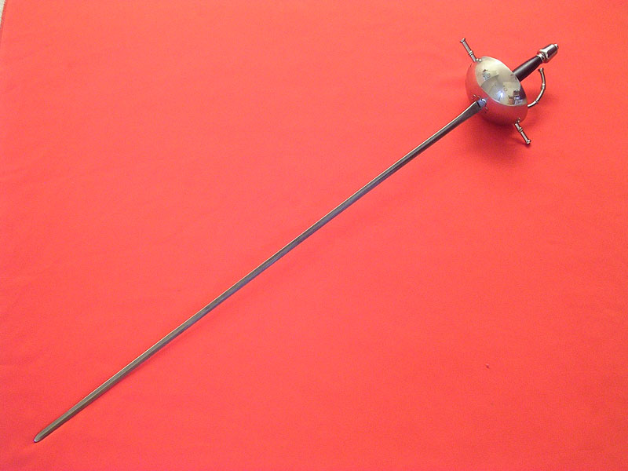this is a picture of a schalger
The Schlager by Burt Struthers
The schlager is an immensely long, thin sword, not much wider than a razor and ground to a razor’s sharpness. It is slightly curved, and has a blunt end and basket hilt to protect your hand. When you fight, you stand close together, one arm behind you, your sword arm crooked and above your head, and all the action is with the wrist. The object is to flick pieces of flesh from the scalp and face of your opponent, and you mustn’t give way an inch, or grimace, and, under no circumstances, emit an “ouch!” or its German equivalent. The bouts take place in a hall, or cockpit, designed for the purpose, and there are numerous spectators, most of them members of the groups involved. There is always a young surgeon in attendance whose duty it is to stop the fight if there is too much loss of blood, or between rounds, to sew up long wounds and doctor small ones. He operates in as brutal a manner as possible in order to further indoctrinate the young men in courage, also in order that the scars may heal badly. This, naturally, is good for the young surgeon, too— it teaches him not to be sentimental I his future practice. If you achieve good wounds, you put salt in them and keep them open to make spectacular scars.
—from his book Daggers I have Known and Loved (Heehaw Publishing, 1925) on page 42. Although the company once located in New Orleans is now out of business, this book was very popular and went into a second printing.

