Essay 3 (15%) 1050 words, due after Thanksgiving

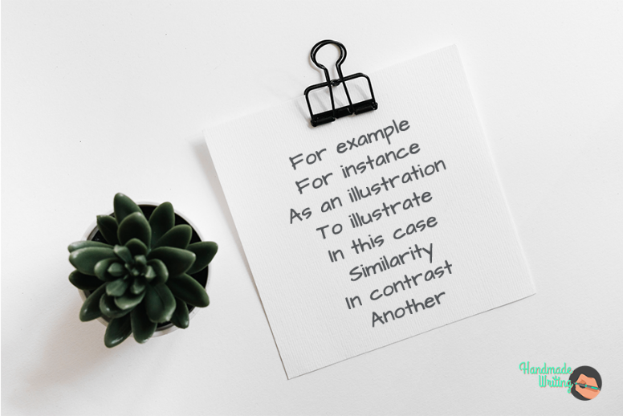

Illustration is the use of examples — interesting facts, samples/examples, secondary sources from good articles and not blogs or poorly designed sites, and anecdotes or stories — to make ideas more concrete and to generalize less by using more specific and detailed examples. Examples enable writers not just to tell but also to show what they mean. The more specific the example, the more effective it is. For instance, in an essay about alternative sources of energy, a writer might offer an example of how a local architecture firm designed a home heated by solar collectors instead of by a conventional oil, gas, or electric system. A writer uses examples to clarify or support the thesis in an essay and the main ideas in paragraphs.

To use illustration effectively, begin by thinking of ideas and generalizations about your topic that you can make clearer and more persuasive by illustrating them with facts, anecdotes, or specific details. You should focus primarily on your main point, the central generalization that you will develop in your essay. Also be alert for other statements or references that may benefit from illustration. Points that are already clear and uncontroversial and that your readers will understand and immediately agree with can stand on their own as you pass along quickly to your next idea; belaboring the obvious wastes your time and energy, as well as your reader’s. Often, how-ever, you will find that examples add clarity, color, and weight to what you say.

Sometimes this is called an example essay because you are providing supportive detailed examples to show something.

Requirements:
Third person
Use examples to illustrate a point or phenomenon
Introduction with hook, background & thesis
Transitions between paragraphs & in front of thesis
MLA format
More formal (One example can be personal/narrative as in one paragraph but still must follow MEAL pattern)
Follow MEAL pattern (Main Idea, Example/Evidence, Analysis, Linking/Concluding)
Minimum 2 secondary source examples (You can have more – there needs to be one for each body paragraph’s supporting example, excluding a personal/narrative one)

Effective examples are:
clear
concrete
vivid (think action verbs, adjectives and the 5 senses)
supportive
connect to the reader

NOT ARGUMENTATIVE
NOT COMPARING & CONTRASTING
NOT A PERSONAL EXPERIENCE
NOT OPINION

Topic Choices:
- Illustrate Americans’ obsession with losing weight
- Illustrate the effects of sugar in surprising foods (ie hamburger buns at McDonalds, Ragu, apple sauce, etc – don’t use those!)
- Illustrate American’s obsession with healthy eating (pick one)
- Illustrate the negative effects of eating pork
- Illustrate the new obsession with smoking alternatives and its effects
- Illustrate American’s obsession with Instagram or Youtube to the point of putting oneself in danger
- Illustrate how a coach can turn a team and even a program around
- Illustrate the beneficial effects of sports on small towns
- Illustrate how a person without hearing or sight can navigate successfully through a day
- Illustrate the problems of America’s modern jail system
- Illustrate the effects of rising global temperatures
- Illustrate how rudeness and rage (car, air, etc) are on the rise (Pick one)
- Illustrate the rise of cyberbullying in today’s teenagers and kids
- Illustrate the effects of doping in modern sports like cycling, baseball, and elsewhere
- Illustrate the surprising effects of marijuana
- Illustrate the public intoxication phenomenon among American college students
- Illustrate the role of one form of media on how women see themselves today

“Our Vanishing Night” by Verlyn Klinkenborg (essay from textbook, rest on p355)
If humans were truly at home under the light of the moon and stars, we would go in darkness happily, the midnight world as visible to us as it is to the vast number of nocturnal species on this planet. Instead, we are diurnal creatures, with eyes adapted to living in the sun’s light. This is a basic evolutionary fact, even though most of us don’t think of ourselves as diurnal beings any more than we think of ourselves as primates or mammals or Earthlings. Yet it’s the only way to explain what we’ve done to the night: We’ve engineered it to receive us by filling it with light.

This kind of engineering is no different than damming a river. Its benefits come with consequences — called light pollution — whose effects scientists are only now beginning to study. Light pollution is largely the result of bad lighting design, which allows artificial light to shine outward and upward into the sky, where it’s not wanted, instead of focusing it downward, where it is. Ill-designed lighting washes out the darkness of night and radically alters the light levels — and light rhythms — to which many forms of life, including ourselves, have adapted. Wherever human light spills into the natural world, some aspect of life — migration, reproduction, feeding — is affected.

For most of human history, the phrase “light pollution” would have made no sense. Imagine walking toward London on a moonlit night around 1800, when it was Earth’s most populous city. Nearly a million people lived there, making do, as they always had, with candles and rushlights and torches and lanterns. Only a few houses were lit by gas, and there would be no public gaslights in the streets or squares for another seven years. From a few miles away, you would have been as likely to smell London as to see its dim collective glow.

Now most of humanity lives under intersecting domes of reflected, refracted light, of scattering rays from over lit cities and suburbs, from light-flooded highways and factories. Nearly all of night-time Europe is a nebula of light, as is most of the United States and all of Japan. In the south Atlantic the glow from a single fishing fleet — squid fishermen luring their prey with metal halide lamps — can be seen from space, burning brighter, in fact, than Buenos Aires or Rio de Janeiro.

In most cities the sky looks as though it has been emptied of stars, leaving behind a vacant haze that mirrors our fear of the dark and resembles the urban glow of dystopian science fiction. We’ve grown so used to this pervasive orange haze that the original glory of an unlit night — dark enough for the planet Venus to throw shadows on Earth — is wholly beyond our experience, beyond memory almost. And yet above the city’s pale ceiling lies the rest of the universe, utterly undiminished by the light we waste — a bright shoal of stars and planets and galaxies, shining in seemingly infinite darkness.

