Directions: Correct the following run-on sentences.
- Blue is my favorite color it is the color of the sky and the sea and it reminds me of my favorite insect which is the butterfly.

- When I get older I want to have a big family similar to my grandparents who each had seven brothers and sisters I like big families and I hope to meet someone who wants to have a large family.

- We usually leave at 11:00 for dance class today is different since it is a national holiday and a time to celebrate with fireworks, hotdogs and an afternoon of fun at the park so we leave thirty minutes earlier.

Run-On Sentence Exercise: read the Paragraph and correct the sentences that are missing the proper punctuation.
Why I Had to Get Rid of the Monster
Although I am a dog-lover by nature, I recently had to give away my three-month-old retriever, Plato. I had several good reasons for doing so. A few months ago I picked up the dog at the Humane Society as a Christmas gift for my girlfriend. Alas, she dumped me on Christmas Eve I was left to console myself by caring for the dog. That's when my true misery began. For one thing, Plato was not housebroken. Throughout the apartment he left little mementos, staining rugs and furniture and fouling the air, he would burrow under any newspapers I laid down for him. To make matters worse, his untamed potty habits were supported by an insatiable appetite. Not content with a sack of Kibbles 'n Bits every day, he would also gnaw at the couch and shred clothes, sheets, and blankets, one night he chewed up a friend's new pair of clogs. Finally, Plato simply wasn't happy being cooped up by himself in a small apartment. Whenever I left, he would begin whimpering, and that soon turned into furious barking.
As a result, my neighbors were threatening to murder both me and the "monster," as they took to calling him. So, after six weeks of life with Plato, I gave him away to my uncle in Baxley. Fortunately, Uncle Jerry is quite accustomed to animal feed, waste, noise, and destruction

Directions: Read the passage below. Then circle the correct multiple choice answer below the passage.

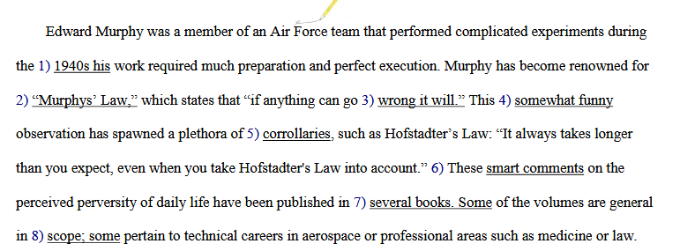

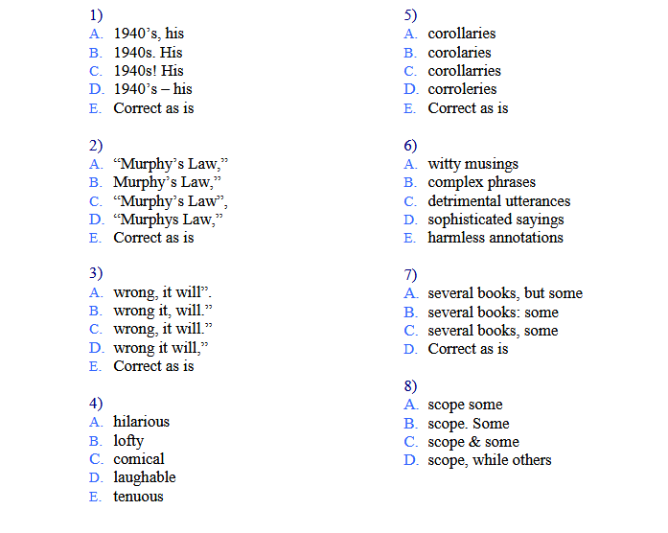
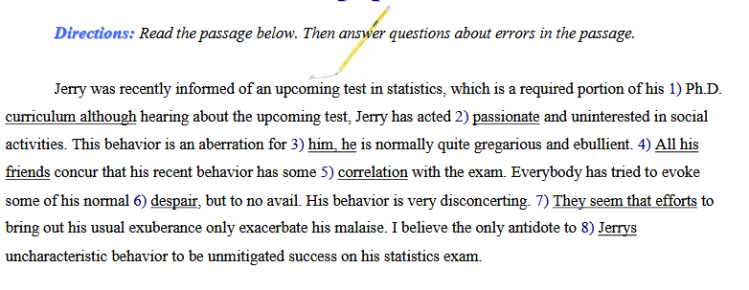
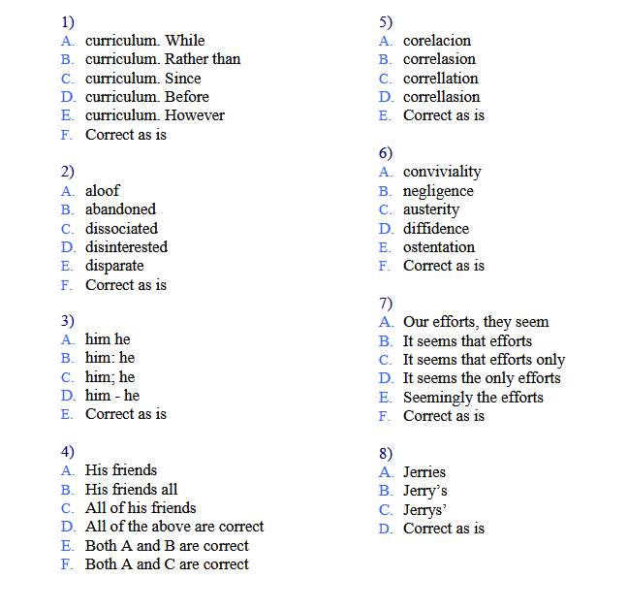
Read the passage and then correct any errors.
The view of star formations offer by the Spitzer Space telescope be one of
disruption through the telescope lens, one can be seen that the creation of a star
disrupt nearby space. The spitzer space telescope that launches in 2003 contradicts
the widely held thinking that mellifluous gas clouds gracefully facilitate the creation
of new stars, early models of star formation concentrating on the evolution of
isolated stars. Whereas recent models have recognized that stars interact
with one other in their stellar neighborhood.
1
2
3
4
5
6
7
8
9
10

Read the passage below and look closely at the verbs.

Mona Lisa
Leonardo da Vinci's "Mona Lisa" is one of the most famous portraits in the history of painting. Leonardo took four years to complete the painting: he begun work in 1503 and finish in 1507. Mona (or Madonna Lisa Gherardini) is from a noble family in Naples, and Leonardo may have paint her on commission from her husband. Leonardo said to have entertain Mona Lisa with six musicians. He install a musical fountain where the water play on small glass spheres, and he give Mona a puppy and a white Persian cat to play with. Leonardo did what he could to keep Mona smiling during the long hours she sit for him. But its not only Mona's mysterious smile that has impress anyone who has ever view the portrait: the background landscape is just as mysterious and beautiful. The portrait can be seen today in the Louvre Museum in Paris.

Instructions: The following passage contains 10 errors in verb tense. The first paragraph has no errors, but each of the remaining paragraphs contains at least one faulty verb form. Identify and correct these errors. When you're done, compare your answers with the key below.

The Worst Tourist
The least successful tourist on record is Mr. Nicholas Scotti of San Francisco. In 1977 he flew from America to his native Italy to visit relatives. En route, the plane made a one-hour fuel stop at Kennedy Airport. Thinking that he has arrived, Mr. Scotti got out and spends two days in New York believing he was in Rome.
When his nephews are not there to meet him, Mr. Scotti assumes they had been delayed in the heavy Roman traffic mentioned in their letters. While tracking down their address, the great traveller could not help noticing that modernization had brushed aside most, if not all, of the ancient city’s landmarks.
He also noticed that many people speak English with a distinct American accent. However, he just assumed that Americans were everywhere. Furthermore, he assumed it was for their benefit that so many street signs were written in English. Mr. Scotti spoke very little English himself and next ask a policeman (in Italian) the way to the bus depot. As chance would have it, the policeman came from Naples and replies fluently in the same tongue.
After twelve hours traveling round on a bus, the driver handed him over to a second policeman. There followed a brief argument in which Mr. Scotti expresses amazement at the Rome police force employing someone who did not speak his own language. Even when told at last that he was in New York, Mr. Scotti refuses to believe it. He was return to the airport in a police car and sent back to California.
–Adapted from Stephen's Pile's Book of Heroic Failures, 1979)

