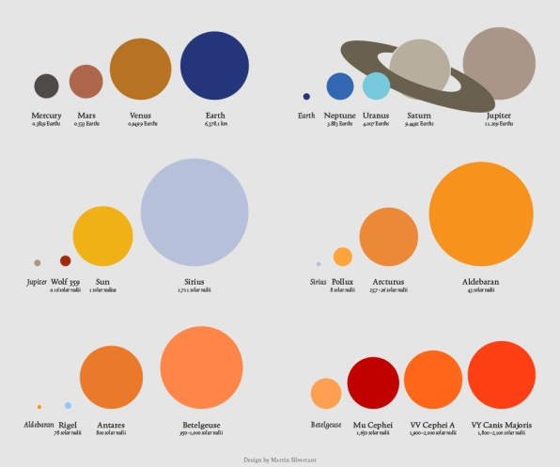
Universal Proportional Thinking Activity
The Earth has a diameter of 12,756 km (7,926 mi).
The Sun has a diameter of 1,392,000 km.
How many times greater is the diameter of the Sun
than the Earth?

Find the volume of the Earth in km³.

Find the volume of the Sun in km³.

How many times greater in volume is the Sun than the Earth?

Picture this: If the Earth had the diameter of a golf ball (1.68”), what would the diameter
of the Sun be to the nearest foot?

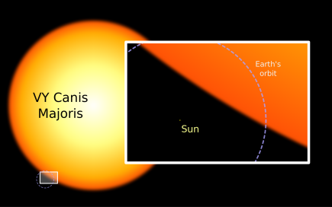
The largest star that has been discovered so far is the hypergiant star,
Canis Majoris, which has a diameter of 2.4 billion km.
The diameter of Canis Majoris is ________ times the diameter of the Sun.
Find the volume of the Canis Majoris in km³.

How many times greater in volume is Canis Majoris than the Sun? Than the Earth?

Picture this: If the Earth had the diameter of a golf ball (1.68”), what would the diameter of Canis Majoris be to the nearest foot?

This diameter is slightly less than the height of Mount Everest (29,029 ft) and
more than Denali (20,236 ft), the tallest mountain in the world. Imagine a golf
ball representing Earth and these mountains representing Canis Majoris.

Now convert this diameter to the nearest mile.
If you walked from the center of the Earth at a speed of 3 miles per hour, it would take 55 days to reach the surface. If you walked from the center of the Sun at a speed of 3 miles per hour, it would take nearly 16.5 years to reach the surface. If you walked from the center of Canis Majoris at a speed of 3 miles per hour, it would take over 28,372 years to reach the surface! Show that one of these three statements is true.

If you filled the state of Texas with as many golf balls as the number of Earths
which would fill Canis Majoris, it would be 22 inches deep in golf balls!

The Sun is 93,000,000 miles away from Earth. At the speed of light (186,000 miles per second), how much time does it take for a ray of light from the Sun to reach the Earth? Give your answer to the nearest second. Then convert this time to minutes and seconds. _______ s = _______ min ______ s

Complete the following conversion involving 1 light-year, the distance a ray of light travels in one Earth year. The speed of light is given as 672,000,000 mph. Express your answer both in standard notation and in scientific notation.

1 light-year = = _________________________mi

= _________________________mi

This is approximately 9.5×10¹² kilometers. Astronomers estimate that the nearest star to Earth after the Sun is the triple-star system known as Alpha Centauri, which is about 4.24 light-years away from the Earth. They also approximate the diameter of the Milky Way galaxy at 100,000 light years across. We live in a vast and amazing universe!
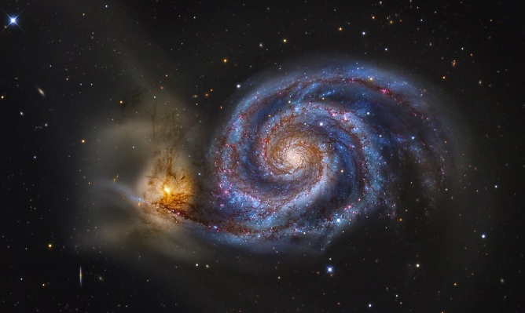
The Whirlpool Galaxy is 31,000,000 light years away from the Earth. How many miles is this picturesque galaxy from the Earth?

[For this and more information, consider viewing https://www.youtube.com/watch?v=EAzCP8SEKwc , a talk by Louie Giglio at Passion City Church in Atlanta, GA.]

