Painted Cube Challenge
Suppose a cube has a length of 3 centimeters for each edge. The cube is then painted red on all exposed sides (or “faces”). Finally, it is cut into 27 smaller cubes, each with length of 1 centimeter for each edge.
How many of these smaller cubes will have red paint on
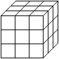
0 sides? _____
1 side? _____
2 sides? _____
3 sides? _____
Check the total. It should be 27.
In a similar way, consider the following 4- and 5-centimeter cubes below, painting all exposed sides red, as well. Complete the table below. Notice that the table includes the 3 cm case above, and extends the problem to a 6-cm cube and to a 2-cm cube. Look for the pattern!
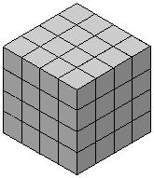

Size of large cube | Number of small cubes with red paint on
 | 0 sides | 1 side | 2 sides | 3 sides
2 cm
3 cm
4 cm
5 cm
6 cm

Do your best! Rise to the challenge! Live and learn!

