Non-Euclidean Geometries Project
In three dimensions, there are three classes of constant curvature geometries. All are based on the first four of Euclid's postulates, but each uses its own version of the parallel postulate. The "flat" geometry of everyday intuition is called Euclidean geometry (or plane geometry), and the non-Euclidean geometries are called hyperbolic geometry (or Lobachevsky-Bolyai-Gauss geometry) and elliptic geometry (or Riemannian geometry). Spherical geometry is a non-Euclidean two-dimensional geometry which is a subset of elliptic geometry. It was not until 1868 that Beltrami proved that non-Euclidean geometries were as logically consistent as Euclidean geometry.
The discovery on non-Euclidean geometries has introduced new objects that depict the phenomena of the universe including fractals. A fractal is “an object whose detail is not lost as it is magnified” (Pappas, 1989, p. 78).
One of the first non-Euclidean geometries to surface, projective geometry developed and played a major part in Renaissance art. It involves problems of perspective with three-dimensional paintings.
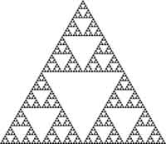
Create a PowerPoint slide show with the following components:
- The history of this geometry
- The specific major tenets or axioms of this geometry
- How this geometry contrasts and compares with Euclidean geometry
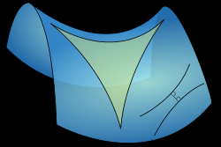
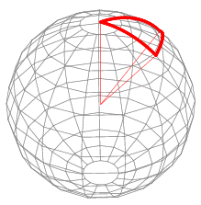
- Practical uses of this geometry
For your topic, please choose between:
- Spherical geometry
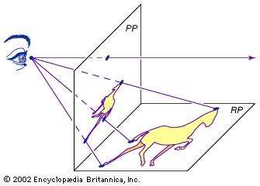
- Elliptical geometry
- Hyperbolic geometry
- Projective geometry
- Fractals

The slide show will be evaluated for its thoroughness in addressing the
four components, for its grammatical quality, and for its creativity. Please
upload your slide show into Desire2Learn Assignments, and plan for a
12-15 minute presentation to your peers.
This project will count as two quiz scores and is due on Monday, April 30. Presentations in class will be on Wednesday, May 2, the last day of class.

Suggested Sources:
Bolyai, J. "Scientiam spatii absolute veritam exhibens: a veritate aut falsitate Axiomatis XI Euclidei (a priori haud unquam decidenda) indepentem: adjecta ad casum falsitatis, quadratura circuli geometrica." Reprinted as "The Science of Absolute Space" in Bonola, R. Non-Euclidean Geometry, and The Theory of Parallels by Nikolas Lobachevski, with a Supplement Containing The Science of Absolute Space by John Bolyai. New York: Dover, 1955.
Bonola, R. Non-Euclidean Geometry, and The Theory of Parallels by Nikolas Lobachevski, with a Supplement Containing The Science of Absolute Space by John Bolyai. New York: Dover, 1955.
Borsuk, K. Foundations of Geometry: Euclidean and Bolyai-Lobachevskian Geometry. Projective Geometry. Amsterdam, Netherlands: North-Holland, 1960.
Carslaw, H. S. The Elements of Non-Euclidean Plane Geometry and Trigonometry. London: Longmans, 1916.
Coxeter, H. S. M. Non-Euclidean Geometry, 6th ed. Washington, DC: Math. Assoc. Amer., 1988.
Dunham, W. Journey through Genius: The Great Theorems of Mathematics. New York: Wiley, pp. 53-60, 1990.
Greenberg, M. J. Euclidean and Non-Euclidean Geometries: Development and History, 3rd ed. San Francisco, CA: W. H. Freeman, 1994.
Harris, J. W., & Stocker, H. "Spherical Geometry." §4.9 in Handbook of Mathematics and Computational Science. New York: Springer-Verlag, pp. 108-113, 1998.
Henderson, D. W. Experiencing Geometry: On Plane and Sphere. Englewood Cliffs, NJ: Prentice-Hall, 1995.
Hopf, H. "Selected Chapters of Geometry." ETH Zürich lecture, pp. 1-2, 1940. http://www.math.cornell.edu/~hatcher/Other/hopf-samelson.pdf.
Iversen, B. An Invitation to Hyperbolic Geometry. Cambridge, England: Cambridge University Press, 1993.
Iyanaga, S., & Kawada, Y. (Eds.). "Non-Euclidean Geometry." §283 in Encyclopedic Dictionary of Mathematics. Cambridge, MA: MIT Press, pp. 893-896, 1980.
Lobachevski, N. Reprinted as "Theory of Parallels" in Bonola, R. Non-Euclidean Geometry, and The Theory of Parallels by Nikolas Lobachevski, with a Supplement Containing The Science of Absolute Space by John Bolyai. New York: Dover, 1955.
Martin, G. E. The Foundations of Geometry and the Non-Euclidean Plane. New York: Springer-Verlag, 1975.
Pappas, T. (1993). The joy of mathematics: Discovering mathematics all around you. Wide World Publishing, Tetra.
Ramsay, A., & Richtmeyer, R. D. Introduction to Hyperbolic Geometry. New York: Springer-Verlag, 1995.
Sommerville, D. Y. The Elements of Non-Euclidean Geometry. London: Bell, 1914.
Sommerville, D. Y. Bibliography of Non-Euclidean Geometry, 2nd ed. New York: Chelsea, 1960.
Sved, M. Journey into Geometries. Washington, DC: Math. Assoc. Amer., 1991.
Trudeau, R. J. The Non-Euclidean Revolution. Boston, MA: Birkhäuser, 1987.
Weisstein, E. W. "Books about Non-Euclidean Geometry." http://www.ericweisstein.com/encyclopedias/books/Non-EuclideanGeometry.html.
Weisstein, E. W. "Spherical Geometry." From MathWorld--A Wolfram Web Resource. http://mathworld.wolfram.com/SphericalGeometry.html
"Welcome to the Non-Euclidean Geometry Homepage." http://members.tripod.com/~noneuclidean/.
Woods, F. S. "Non-Euclidean Geometry." Ch. 3 in Monographs on Topics of Modern Mathematics Relevant to the Elementary Field (Ed. J. W. A. Young). New York: Dover, pp. 93-147, 1955.
Zwillinger, D. (Ed.). "Spherical Geometry and Trigonometry." §6.4 in CRC Standard Mathematical Tables and Formulae. Boca Raton, FL: CRC Press, pp. 468-471, 1995.

