Constructions 102 Name ___________________________
Using only a compass and a straightedge …
1. Copy the given triangle.

2. Construct a triangle with the two sides and included angle given.

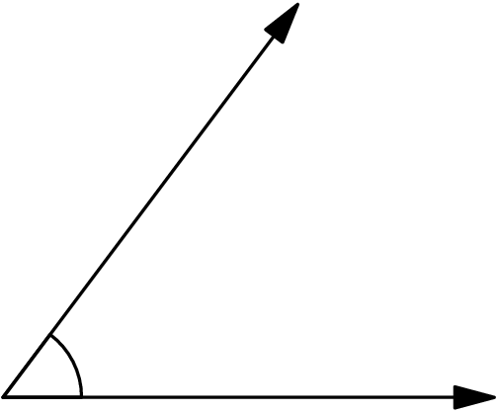

3. Construct a triangle with the two angles and included side given.
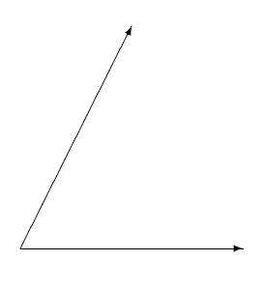

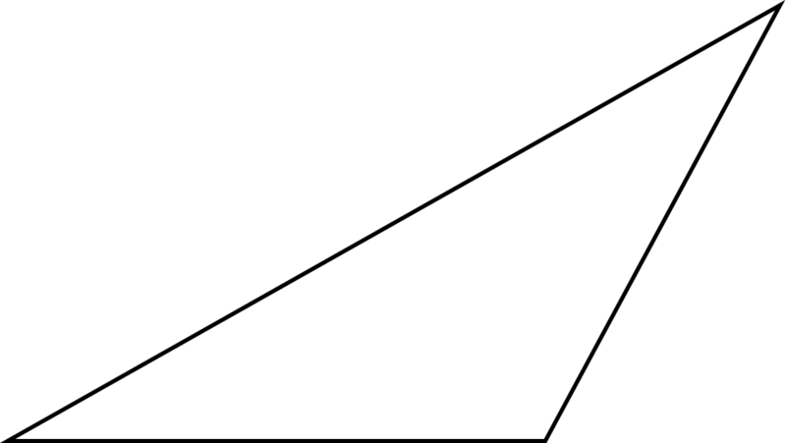
4. Construct (a) an altitude and (b) a median of the given triangle.

5. Construct (a) the incenter, (b) the circumcenter, (c) the centroid, and (d) the orthocenter of the given triangle. Also include the incircle and the circumcircle in your drawing.

