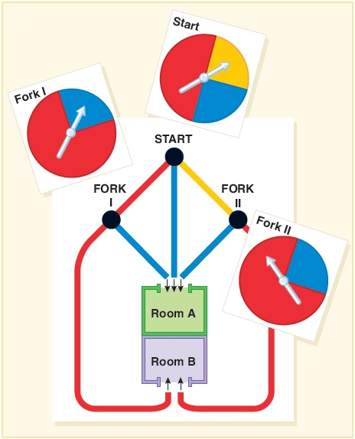

Spinning the start spinner sends you straight into Room A or toward Fork I or Fork II. Then spin those spinners and follow the path which matches the color the spinner arrow “lands in”. With work to support your solution (A tree diagram showing each stage is strongly suggested.), find the probability for this game of going into _______. Give simplified fraction solutions.
(a) Room A (b) Room B

