Addition and Subtraction of Whole Numbers
Methods KEY

I. Perform the following addition problem using 5 different methods:

4837 + 3519

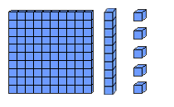
(a) Concrete (Base 10 Blocks)
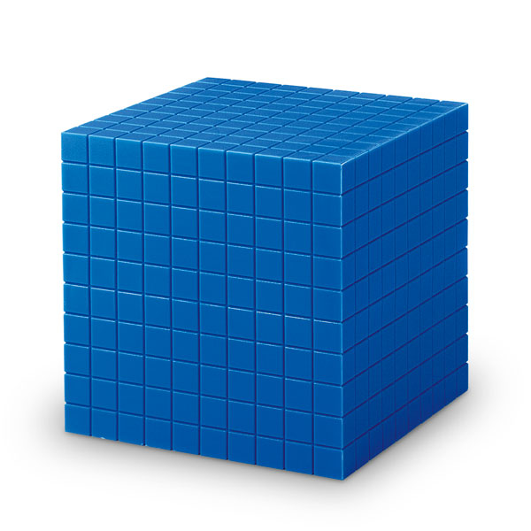
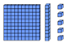

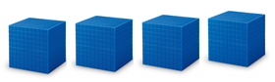

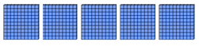

After combining and trading (10 units for 1 long and 10 flats for 1 block), we have 8 blocks (each representing 1000), 3 flats (each representing 100), 5 longs (each representing 10) and 6 units (each representing 1). The answer, then, is 8,356.

(b) Standard Algorithm (c) Denominate

1 1
4 8 3 7 4 thousands 8 hundreds 3 tens 7 ones
+ 3 5 1 9 + 3 thousands 5 hundreds 1 ten 9 ones
8 3 5 6 7 thousands 13 hundreds 4 tens 16 ones
8 thousands 3 hundreds 5 tens 6 ones = 8,356

[Trade 10 ones for 1 ten and 10 hundreds for 1 thousand]

(d) Left-to-Right or Scratch (e) Expanded

4 8 3 7 4 8 3 7 4000 + 800 + 30 + 7
+ 3 5 1 9 + 3 5 1 9 + 3000 + 500 + 10 + 9
7 0 0 0 7 3 4 6 7000 + 1300 + 40 + 16
1 3 0 0 8 5 = 8000 + 300 + 50 + 6
4 0
1 6 The answer is 8,356.
8 3 5 6

II. Perform the following subtraction problem using 3 different methods:

342 – 86

(a) Concrete (Base 10 Blocks (b) Dutch

3 4 2
̶ 8 6
300 – 40 – 4 [Think 300 – 0,
= 260 – 4 40 – 80, and
̶ = 256 2 – 6.]

[After borrowing 10 units from a long, and then borrowing 10 longs from a flat, this diagram illustrates the “take away model” for subtraction, symbolized by the s. The final result is 2 flats, 5 longs, and 6 units, or 256.]

(c) Standard Algorithm

2 13 12
3 4 2
− 8 6
2 5 6

Multiplication and Division of Whole Numbers
Methods KEY

III. Perform the following multiplication problem using 5 different methods:

43 x 28

(a) Concrete (Base 10 Blocks)
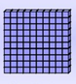
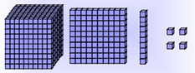
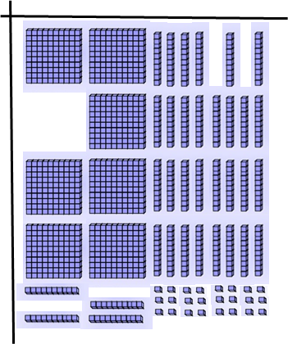

Trade 20 units for 2 longs.
Then trade 40 longs for 4 flats.
Then trade 10 flats for 1 block.
The final result is 1 block, 2 flats, and 4 units.

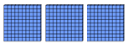

(b) Standard Algorithm (c) Partial Products or “FOIL”

2
4 3 4 3
× 2 8 × 2 8
3 4 4 2 4 8 × 3
8 6 0 3 2 0 8 × 40
1 2 0 4 6 0 20 × 3
8 0 0 20 × 40
1 2 0 4

(d) Lattice (e) Russian Peasant
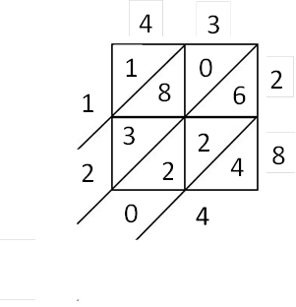

Double Half

43 × 28
86 14
☺172 7
☺344 3
☺688 1
1204

[Add the numbers on the double side corresponding to the odd factors on the half side to get the product.]

IV. Perform the following division problem using 2 different methods:

5617 ÷ 23

(a) Repeated Subtraction (b) Standard Algorithm
2 4 4
23 5 6 1 7 23 5 6 1 7
̶ 2 3 0 0 100 ̶ 4 6
3 3 1 7 1 0 1
̶ 2 3 0 0 100 ̶ 9 2
1 0 1 7 9 7
̶ 4 6 0 20 ̶ 9 2
5 5 7 5
̶ 4 6 0 20
9 7 The answer is 244 r. 5 or 244 ⁵/₂₃.
̶ 4 6 2
5 1
̶ 4 6 2
5

The quotient is 224, and the remainder is 5.

*(c) Partitioning with concrete (base 10 blocks)

If Maggie wants to share her 783 extra jelly beans with 5 friends so that each friend gets the same number, how many should each get? How many will be left over?
783 ÷ 5 *Using base 10 blocks is best for division problems with smaller divisors (than the problem modeled in parts (a) and (b)).
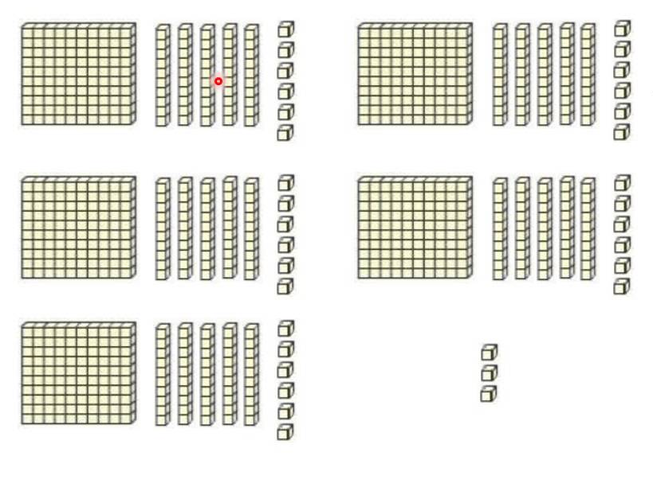

The quotient is 156, and the remainder is 3. Each friend should get 156 jelly beans. There will be 3 jelly beans left over.

