Mathematics Literature Project

Visit our Gordon Hightower Library (or another library in our university system) and the Smith Hall Resource Library, and read a children’s book from the following list:

Anno, M. (1995). Anno’s magic seeds. New York, NY: Philomel Books.

Appelt, K., & Sweet, M. (1999). Bats on parade. New York, NY: Morrow Junior Books.

Kanninen, B. & Bloch, S. (2018). Circle rolls. New York, NY: Phaidon.

Kroll, V., & O’Neill, P. (2005). Equal shmequal: A math adventure. Watertown, MA: Charlesbridge Publishing.

Litwin, E., & Dean, J. (2012). Pete the cat and his four groovy buttons. New York, NY: Harper.

Murphy, S. J., & Cravath, L. (1999). Spunky monkeys on parade. New York, NY: Harper Collins Publishers.

Pinczes, E. J., & Mackain, B. (1993). One hundred hungry ants. New York, NY: Houghton Mifflin.

Schwartz, D. M., & Kellogg, S. (1985). How much is a million? New York, NY: Harper Collins Publishers.

Scieszka, J., & Smith, L. (1995). Math curse. Singapore: Viking.

Tang, G., & Cahoon, H. (2004). Math fables. Singapore: Scholastic Press.

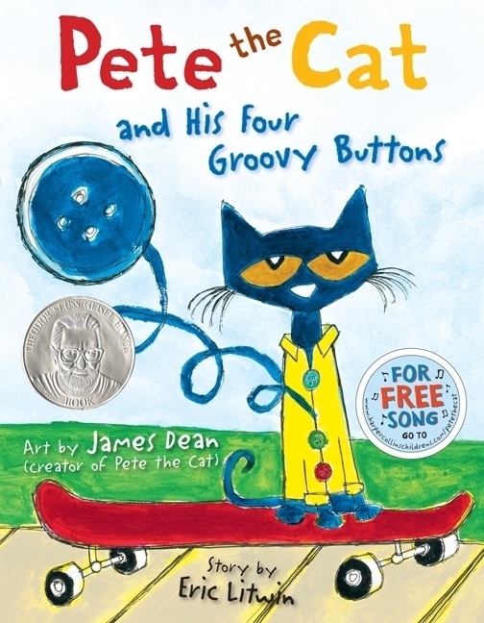
With our course’s emphasis on data analysis, probability, and connections to other mathematics content, take one of the books, and develop a mini-lesson, gradually helping your students discover some significant data analysis, probability or other mathematics content.

In your mini-lesson plan, please include:
(1) Target grade level, subject area, expected total duration of mini-lesson
[20 points]
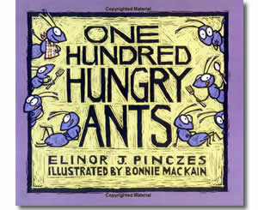
(2) The relevant CCSSM standard showing the target grade level [10 points]

(3) Step-by-step procedures for the topic including detailed examples from
the book and a few activities that clearly involve class participation.
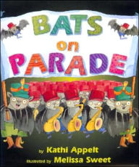
Aim for thoroughness, a flow from less to more difficult, and creativity. [60 points]

(4) Citations/List of references/Resource list [10 points]


