MLB Home Run Statistics Project Name __________________

Refer to the given chart. The data show Hank Aaron’s entire career with the Milwaukee Braves, Atlanta Braves, and Milwaukee Brewers and George Herman “Babe” Ruth’s entire career with the Boston Red Sox and the New York Yankees. Albert Pujols’ data involves many years with the St. Louis Cardinal and the Los Angeles Angels, but his career continues. Mike Trout, also with the Angels, is early in his career.

Season | Aaron (1954-1976) | Ruth (1914-1935) | Pujols (2001-present) | Trout (2011-present)
1 | 13 | 0 | 37 | 5
2 | 27 | 4 | 34 | 30
3 | 26 | 3 | 43 | 27
4 | 44 | 2 | 46 | 36
5 | 30 | 11 | 41 | 41
6 | 39 | 29 | 49 | 29
7 | 40 | 54 | 32 | 33
8 | 34 | 59 | 37 | 39
9 | 45 | 35 | 47 | 45
10 | 44 | 41 | 42 | 17*
11 | 24 | 46 | 37
12 | 32 | 25 | 30
13 | 44 | 47 | 17
14 | 39 | 60 | 28
15 | 29 | 54 | 40
16 | 44 | 46 | 31
17 | 38 | 49 | 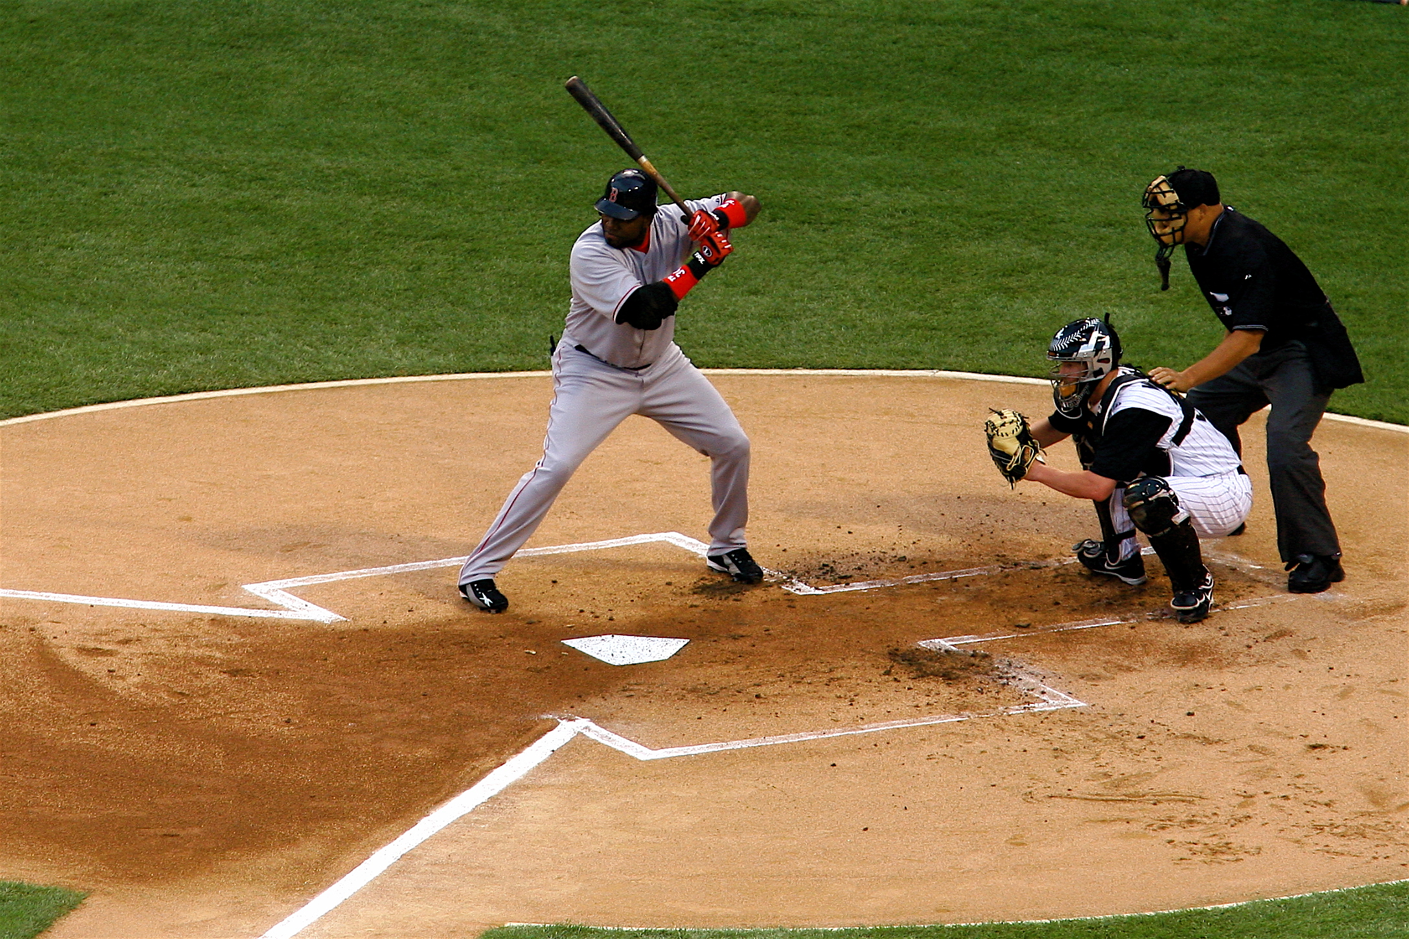  23
18 | 47 | 46 | 19
19 | 34 | 41 | 23
20 | 40 | 34 | 6*
21 | 20 | 22
22 | 12 | 6
23 | 10
* Covid-19 season (only 60 games)
Calculate the following 1-variable statistics on each player’s home run data. Record the answers below, rounding the mean and standard deviation to the nearest tenths place. Show your sorting work above and the rest of the work/rationale below for quartiles, mode(s), range, midrange, mean, and standard deviation. [Last updated October 2020 with the source: baseball-reference.com]. For Pujols and Trout, do not use the Covid-19 season “outliers”.

Statistic | Aaron’s HR | Ruth’s HR | Pujols’ HR | Trout’s HR
Mean

Median

Mode(s)

Midrange

Range

Standard  Deviation | σ = | σ = | s = | s =
Interquartile Range
Make a box plot for each player’s home run data. Use a number line for scaling the box plot proportionally.

Aaron

Ruth

Pujols

Trout

Number Line:

The following multiple line graph shows the home run totals by season for four very strong home run hitters in professional baseball over their careers. Study the data and the graphs, and decide “who’s who?”

Legend: × __________ ■ __________ ▲ __________ * __________
Purple Red Green Blue

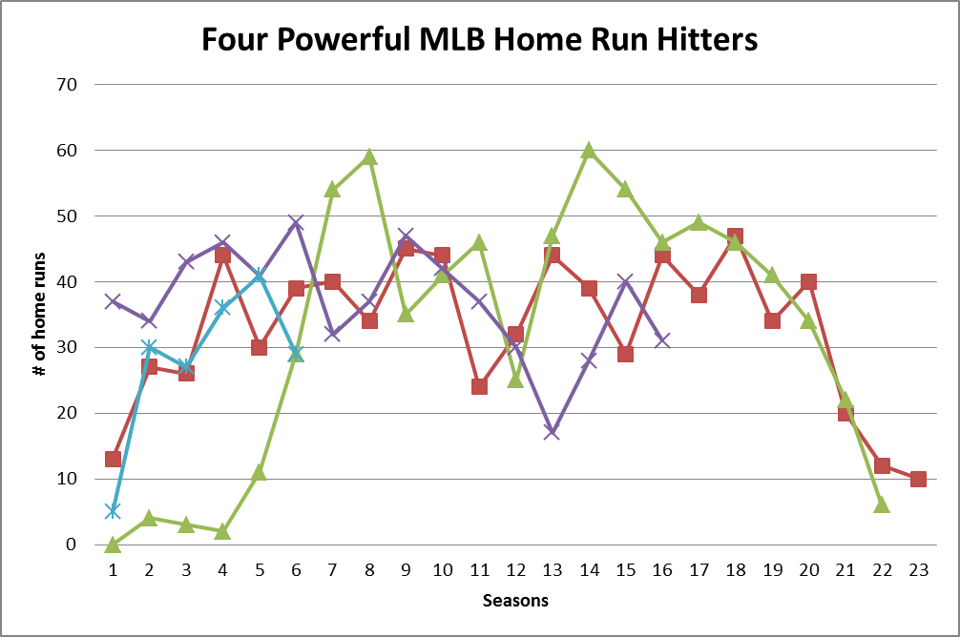

Compare the 4 players’ statistics with 3 statements involving measures of center, variability, and position.

