Geometric Transformations: Translations (“Slides”), Reflections (“Flips”), and Rotations (“Turns”)
Name __________________________
1. Translations
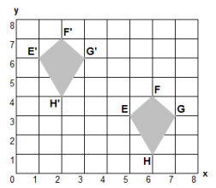
(a) Draw the vector that translates kite EFGH to kite E’F’G’H’.

Write this same vector in algebraic notation: (x, y) ( _____ , _____ )
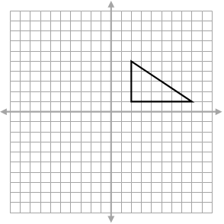
(b) Carry out an (x, y) (x – 10, y + 5) translation of the following triangle.

2. Reflections
Reflect the following triangle over the
(a) x-axis (b) y-axis
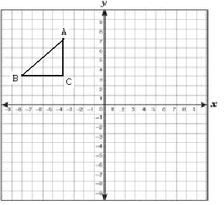

3. Rotations
Find the center of rotation and the angle of rotation that maps the gray letter F onto its red image.
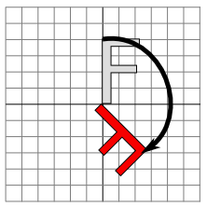

If the origin is the center of rotation, find the angle of rotation that maps figure A onto
B _____ C _____ and D _____ .
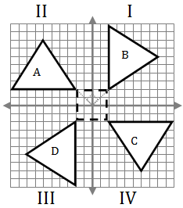

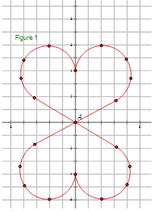
4. Thoroughly discuss the symmetries of the following diagrams (point, turn, and line) with details about the angles of rotation and the lines of symmetry.
(a) (b)

