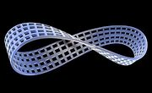
Moebius Strip Activities
Materials:
Long rectangular strip of card stock or paper
Scissors
Tape
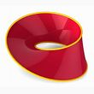
- Cut a long strip of paper. The strip should be about 1 centimeter across, and the length, l, should be much longer than the width, w.
- Bring the ends together to make a simple loop.
- Before attaching the ends together, add a single half-twist to
one side of the strip (as in the image to the right). The result
should look something like this. You have made a Mobius strip.

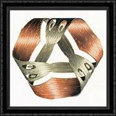
A Möbius strip, band, or loop (US: MOH-bee-əs, MAY-, UK:; German: [ˈmøːbi̯ʊs]), also spelled Mobius or Moebius, is a surface with only one side (when embedded in three-dimensional Euclidean space) and only one boundary or edge. The Möbius strip has the mathematical property of being unorientable. Its discovery is attributed to the German mathematicians Johann Benedict Listing and then independently August Ferdinand Möbius in 1858, though a structure similar to the Möbius strip can be seen in Roman mosaics dated circa 200–250 AD.
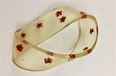
This bracelet is being offered for $850 on eBay.

This wood frame costs $199 at WalMart.

Your activity:
1. Make a Moebius strip using the directions above.
- Put a dot on one side of the paper in the middle (of the paper’s width). Do you suspect that your
dot is on the inside or outside of the strip? __________
Then use a pen, pencil, or marker to start drawing a line in the middle of the paper from that point. Keep going. Any surprises?

Now, based on your dot work, does the paper have an inside or an outside? __________
Therefore, a Mobius strip has one side (with inside = outside).
How many edges does it have? _______
- Cut the paper on the middle line as far as you can. What does this process form?
- Take a photo of both your original Mobius strip (from #1) and the one you found in #3. Include
this/these photo(s) with the answers to these questions (in #2 and #3).

