Measurement Quiz Name ____________________

1. The distance around a rectangular room is 40 feet, and 96 tiles (each one is 1 square foot in size) are needed to cover the floor in the room. What are the room’s dimensions?

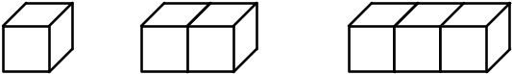
2. In the following sequence, the figures are made of cubes that are glued together. If only the exposed surfaces need to be painted (i.e., after gluing), how many squares will be painted in the 10th figure?

Convert the measurements.

3. 60 ft = __________ yd 4. 42,240 feet = __________ mi

5. 329 in. = __________ yd 6. 0.75 mi = ___________ ft

7. Convert your height and weight to metric measurements.

(a) _____ ft _____ in. = __________ in. = _________ cm = _________ m

(b) __________ lb = __________ kg

8. The circumference of a circle is 350 cm. What is its radius?

9. Sarah reports that the radius of a circle is 6 cm, and its circumference is 36π cm. Explain whether or not she is correct.

10. Determine the area of the shaded region on each of the following geoboards if the unit of measure is 1 cm².

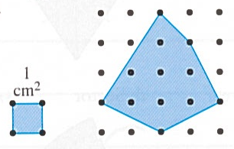
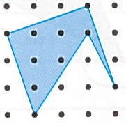
(a) (b)

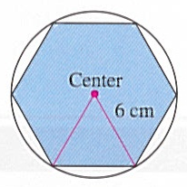
11. Use the figure shown to find each of the following areas.

(a) The area of the regular hexagon

(b) The area of the circle

Find the perimeter of the parallelogram.

12.
21 m
26 m

Solve.

13. Mel plans to fence his yard for his new puppy. The yard is a 30 ft by 54 ft rectangle. Fencing costs $15 per 10 ft section. What is the cost of the fence?

14. Find the side length of a square with the same perimeter as a circle with radius 5 in. Use 3.14 for π. Multiple choice.

(a) 7.85 in. (b) 15.7 in. (c) 3.93 in. (d) 5.6 in.

Choose the most reasonable unit of measure.

15. Basketball court length: 27 _____ (mm, cm, m, km)

16. Pencil width: 0.4 _____ (in., ft, yd, mi)

17. Area of door: 18 _____ 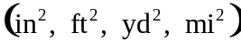

18. Area of a lake: 4 _____ 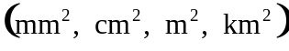

Find the area.
45 mi
48 mi
19.

Find the area.
14 ft
34 ft
23 ft
55 ft

20. 21.
40.0 in.
19.0 in.

Find the surface area of the given figure.

22. Cube, each side is 24 cm 23. A sphere with r = 3.7 yd. Multiple choice.

(a) 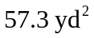
(b) 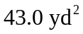
(c) 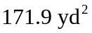
(d) 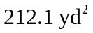

Solve.

24. Three people build a rectangular (prism-shaped) shed 7 ft wide, 5 ft long, and 6 ft high. About how many cubic feet does the shed contain?

(a) 18 (b) 107 (c) 210 (d) 1,470

25. Find the volume of a sphere with radius 11 in. Use 3.14 for π. Round to the nearest tenth.

(a) 5,572.5 in³ (b) 1,520.0 in³ (c) 380.0 in³ (d) 506.6 in³

26. Convert 900°C to Fahrenheit. Use the formula 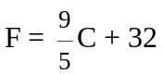.

(a) 1,626.4°F (b) 527.0°F (c) 1,652°F (d) 1,677.6°F

27. A 5-kilometer roadway under construction is being completed at a pace of one-tenth of its length per week. After 5 weeks, how many meters need to be completed?

(a) 2.5 m (b) 2,500 m (c) 25 m (d) 250 m

28. Find the distance between the two points (7, 4) and (-4, -4). Multiple choice.

(a) 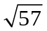 (b) 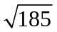 (c) 3 (d) 88 (e) None of these

29. Write the equation of the circle satisfying the given conditions. Multiple choice.

Center at (-6, 0) with a radius of 4

(a) 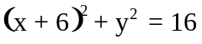 (b) 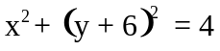 (c) 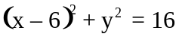
(d) 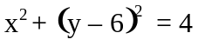 (e) None of these

30. Graph this circle with center at (-6, 0) and radius 4 on the coordinate grid.
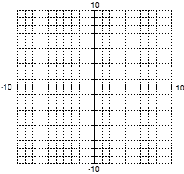

31. Find the area of each shaded region in the following figures.
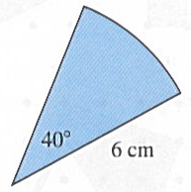
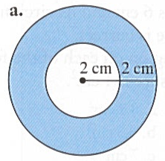
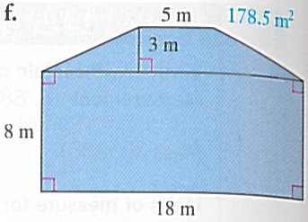
(a) (b) (c) Sector

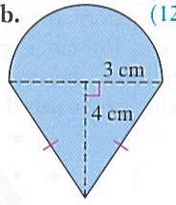
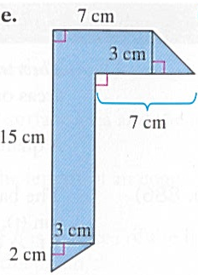
(d) (e) (f) Parallelogram
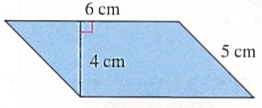

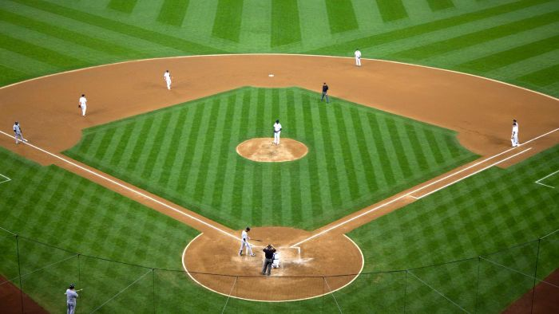
32. A baseball diamond is actually a square with 90 ft on a side. What is the distance a catcher must throw the ball from home plate to second base?

33. Find the length of segment AG in the spiral shown (a.k.a. The Wheel of Theodorus).
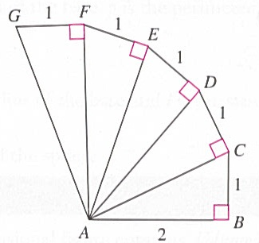

34. Determine whether each group of measures represent sides of a right triangle.

(a) 5 cm, 12 cm, 13 cm

(b) 40 ft, 60 ft, 80 ft

35. Find the surface area of the following box. Include the top and bottom.
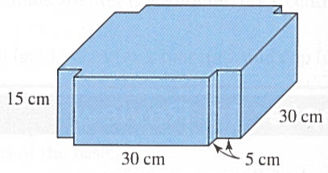

36. Find the surface area and volume of the following figures.

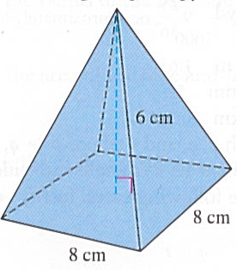
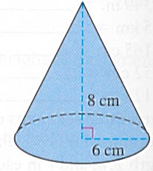
(a) Right square pyramid (b) Right circular cone

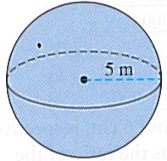
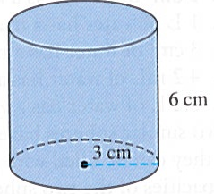
(c) Sphere (d) Right circular cylinder

(e) Right rectangular prism
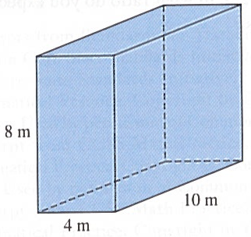

37. Doug’s Dog Food Company wants to impress the public with the magnitude of the company’s growth. Sales of Doug’s Dog Food doubled from 2012 to 2014, so the company is displaying the following graph, which show the radius of the base and the height of the 2014 dog food can to be double those of the 2012 dog food can. What does the graph really show with respect to the company’s growth? Explain your answer.
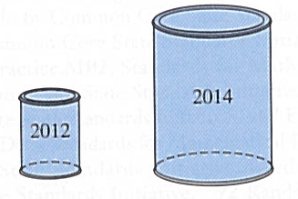

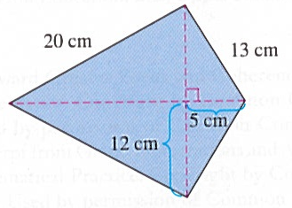
38. Find the area of the kite shown in the figure.

39. Find the area of the triangle with side lengths

(a) 5 m, 5 m, and 7 m. (b) 3 ft, 4 ft, and 5 ft.

40. What is the length of the diagonal of a 8 ½ × 11 in. piece of paper?

41. On 5 × 5 geoboard paper,
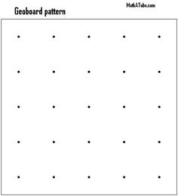
(a) Draw a polygon whose perimeter is greater than 16 units.

(b) Draw a polygon with the least perimeter.

(c) Draw a polygon with the greatest area.

42. Complete each of the following with the appropriate number or metric unit.

(a) A VERY, VERY heavy object has mass that is measured in ____________________ .

(b) A cube whose length, width, and height are each 1 cm has a volume of __________ .

(c) If the cube in part (b) is filled with water, the mass of the cube is __________ , and
the capacity of the cube is __________ .

(d) If a car uses 1 L of gas to go 12 km, the amount of gas needed to go 300 km is ___ L.
(e) 165 cm = __________ m (f) 10 km = __________ m

(g) 35 mm = __________ cm (h) 53,000 m = __________ km
(i) 51.8 L = __________ cm³ (j) 10 km² = _______________ m²

(k) 50 L = ___________ mL (l) 257 mL = _______ L

(m) 52,813 g = _______________ kg (n) 4,800 kg = __________ t

(o) 5 m² = _______________ mm²

43. A storage tank that is a right rectangular prism is 1 m × 2 m × 3 m. If the tank is filled with water, what is the mass of the water in kilograms? In metric tons?

44. For each of the following scenarios, fill in the blank with a metric measurement unit to make it reasonable.

(a) Anna filled the gas tank with 80 _______ of gas.

(b) An adult man has a mass of 82 _______ .

(c) The textbook has a mass of 978 _______.

(d) A nickel has a mass of 5 _______ and is worth 5 ¢.

(e) A typical adult cat has a mass of about 4 _______ .

(f) A compact car has a mass of about 1.5 _______.

(g) The amount of coffee in the cup is 180 _______.

45. Decide if the following statement is likely or unlikely.

(a) Carrie’s bath water has a temperature of 15°C. ______________

(b) Anna found 26°C too warm, so she lowered her thermostat to 23°C. ______________

(c) Jim is drinking water that has a temperature of -5°C. ______________

(d) The water in the teakettle has a temperature of 120°C. ______________

(e) The outside temperature dropped to 5°C, and ice appeared on the pond.
______________

Do your best! Live and learn!

