**Graceful Tree Problems**

Goal: To place consecutive odd numbers in the circles in such a way that the connectors have all the   
 consecutive even numbers. Each tree has all the circles connected with no loops. Each   
 connector has the result from subtracting its adjacent circle numbers. The tree is graceful if it   
 can be solved. That all trees can be solved is a conjecture that has never been proven (and   
 would be worth a lot if you can do it). This is a classic set of problems in graph   
 theory/combinatorics (Cahit, 1990; Fang, 2020; Hartsfield & Ringel, 2013).

The source and inspiration of many of these problem is the following Youtube video:   
<https://www.youtube.com/watch?v=HJ-MotpqFPY&t=79s>



Similar to the dragonfly solution above, solve the butterfly problem with the numbers  
1-11.



Solve this crab problem using 1-13 in the circles and connectors.

Solve this snake (or caterpillar)  
problem using 1-9 in the circles  
and connectors.

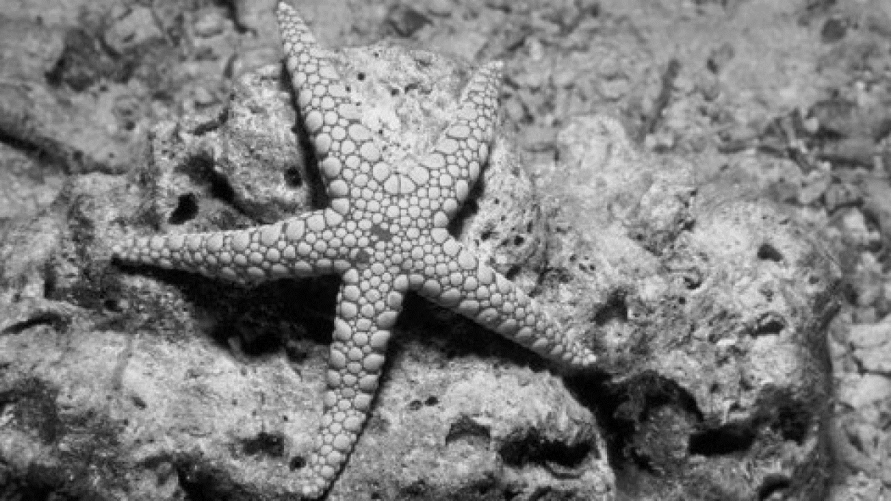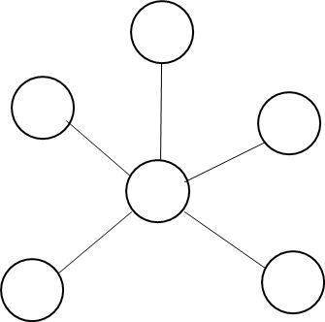

Solve the starfish problem using   
the numbers 1-11 in the circles   
and connectors.