Dilations (Similar Figures) Name ________________________

1. For the given dilations, the center is (0, 0). Find the scale factor.
(a) __________ (b) __________
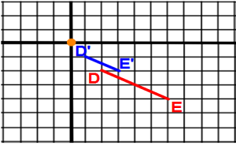
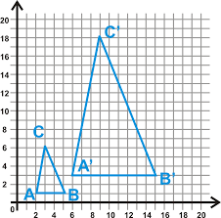

2. For the given dilation, find the scale factor, and write the relationship between the two triangles. Write a proportion using corresponding sides of these similar triangles.
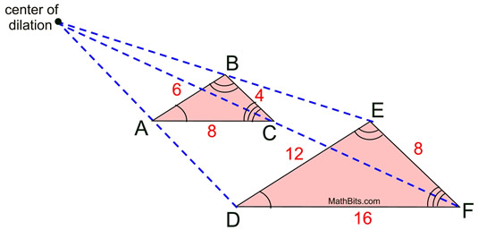

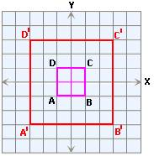
3. For the given dilation, the center is (0, 0). Find the scale factor. __________ Then compare the perimeters and areas of the two squares.

4. Find the image of the given square using the given center of dilation and scale factor 2. Label new points using prime notation, and list all of the object and image coordinates.
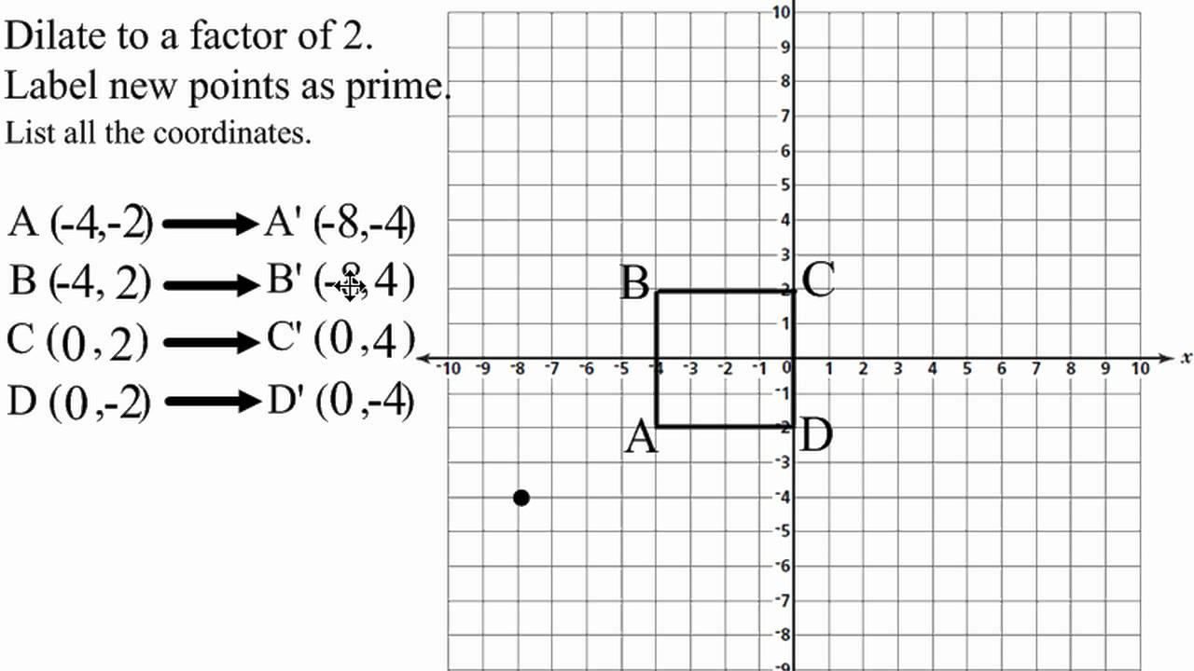

A ____________
B ____________
C ____________
D ____________

A’ ____________
B’ ____________
C’ ____________
D’ ____________

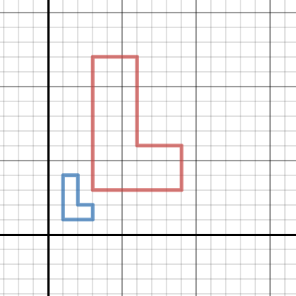
5. For the given dilation, the center is (0, 0). Find the scale factor. __________ Then compare the perimeters and areas of the two concave hexagons.

