Constructions 102 Name ___________________________
Using only a compass and a straightedge . . . [Problems 1-3 employ the SSS, SAS, and ASA Postulates.]
1. Copy the given triangle.

2. Construct a triangle with the two sides and included angle given.

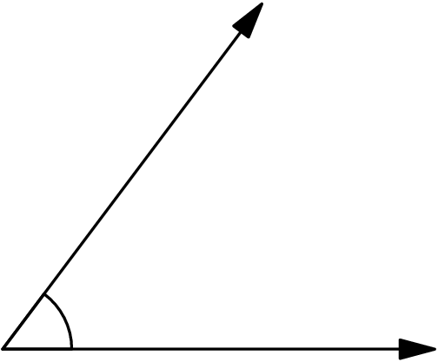

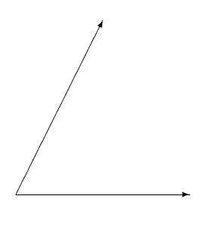
3. Construct a triangle with the two angles and included side given.

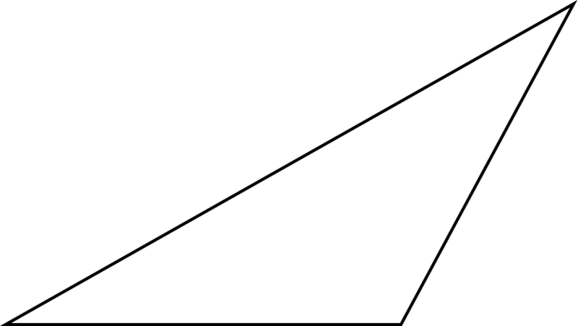
4. Construct (a) an altitude and (b) a median of the given triangle.

5. Construct (a) the centroid, and (b) the orthocenter of the given triangle.

6. Construct (a) the incenter and (b) the circumcenter of the given triangle. Also include the incircle and the circumcircle in your drawing.

