Constructions 101 Name ___________________________
Using only a compass and a straightedge …
1. Construct a line segment with the same length as the given line segment.

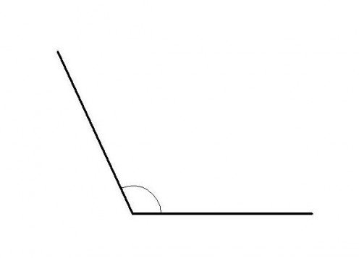
A
2. Construct an angle with the same measure as the given angle.

3. Construct the perpendicular bisector of a given line segment.

4. Construct a line perpendicular to a given line through a given point on the line.
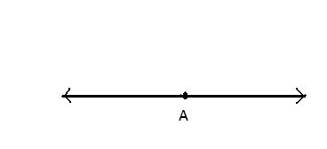

5. Construct a line perpendicular to a given line through a given point not on the line.

6. Construct a bisector of a given angle.
