Congruence and Similarity with Constructions & Transformations Quiz Solutions

1 (a) ∆ABD ∆CBD (by Side-Angle-Side)
(b) ∆ABC ∆EDC (by Angle-Angle-Side or Hypotenuse-Angle)
(c) ∆ABC ∆ADC (by Side-Side-Side). This leads to ∆ABE ∆ADE (by Angle-Side-
Angle) and ∆EBC ∆EDC (by Angle-Side-Angle). With CPCTC, you can then say
that ∆EBC ∆EDC by SAS and also ∆ABE ∆ADE by SAS.
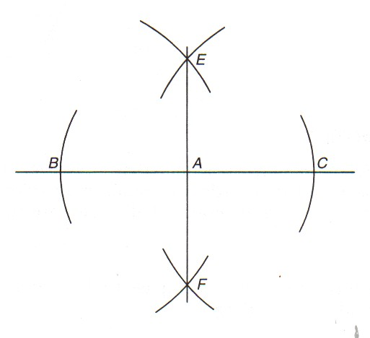
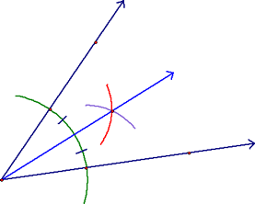
A
2. (a) (b)

(c) (d)
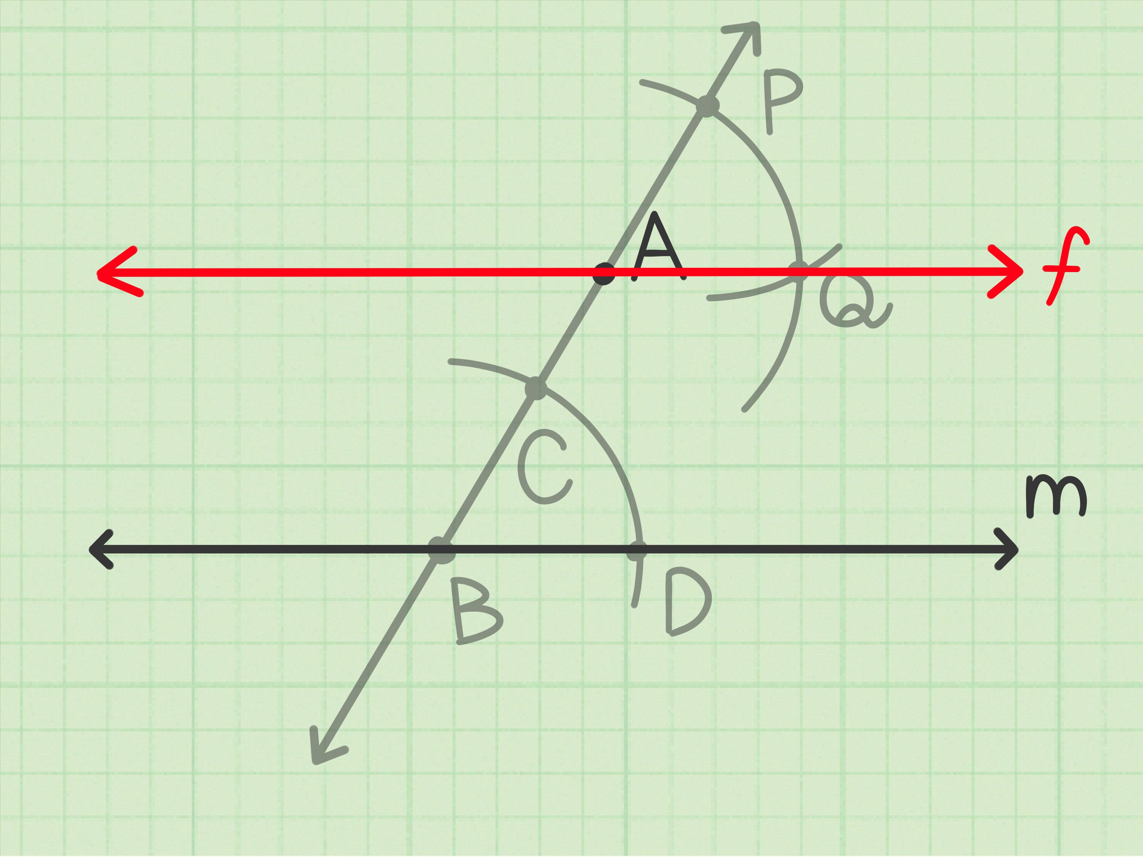
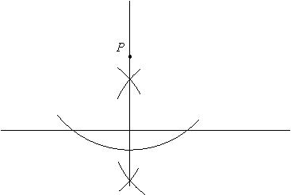
B

3. AECF is a parallelogram. ∆EDF ∆FBC (by Side-Angle-Side), with 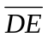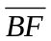(Given),
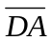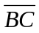(All 4 sides of a square are congruent), and <D <B (All 4 angles of a square are congruent).

Then, since the triangles are congruent, we have 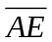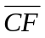. Since 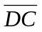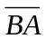 and
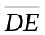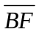, 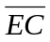 must be congruent to 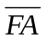.

With 2 pairs of opposite sides congruent, AECF must be a parallelogram.

4. (a) x = 8, y = 5 (b) x = 6.5, WY = 6

5. 24.75 ft or 24’9”

6. 15

7. (a) 70° (b) 62° (c) 48°

8. AB = 6 , BC = 11 , AC = 11

9. 12 m

10. (i) No (ii) Yes (iii) Yes

11. 51.2 m

12. No. They must also bisect each other.
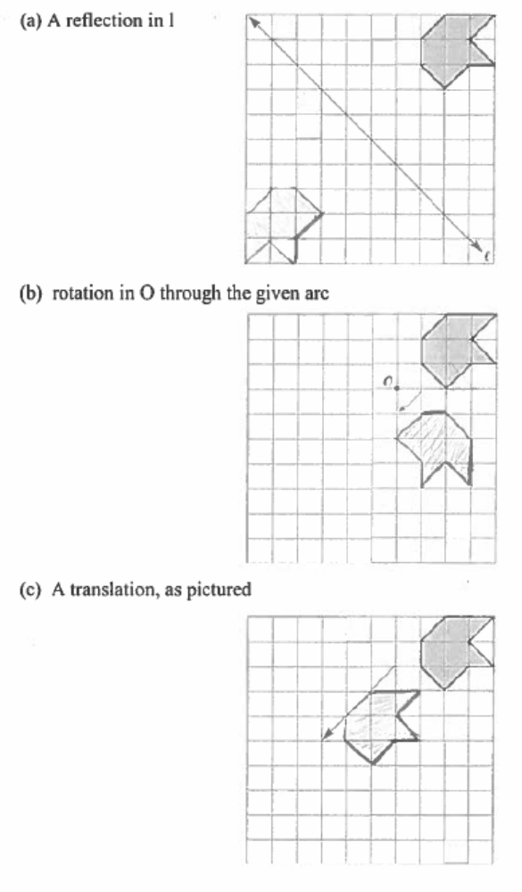
13.

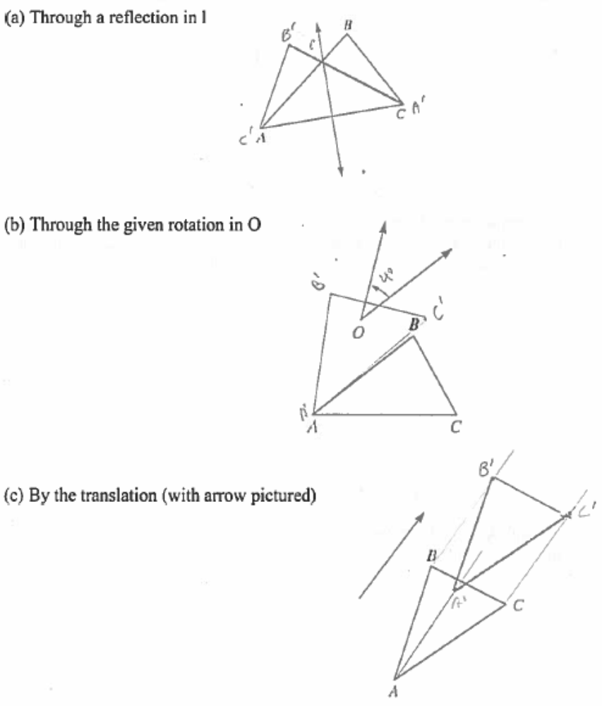
14.

15. (a) There are 4 lines of reflection (vertical, horizontal, and two diagonals) and 3 rotations
(90°, 180°, 270°).

(b) The figure has 180° rotational (point) symmetry, but no reflectional symmetry.
(c) There is one line of reflection (through the center of the circle and the vertex of the
exterior angle), but the figure has no rotational symmetry.

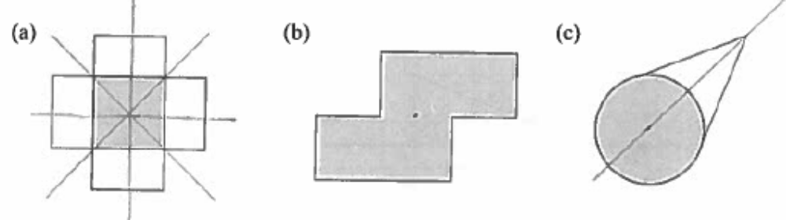

16. Answers may vary. E.g., (a) A, M, or T (b) S, O, or N

17. Answers may vary. E.g., (a) maple leaf (b) starfish
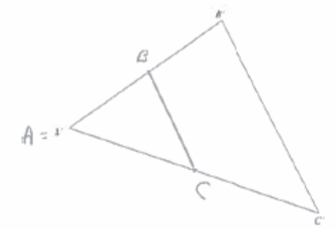
18.

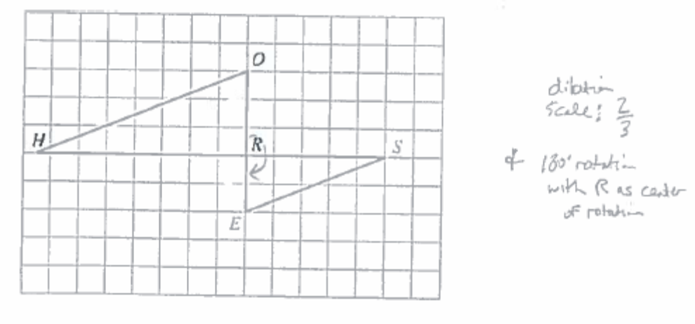
19.

20. (a) Answers may vary. E.g., (0, 4), (2, 0) (b) (-2, 7), (0, 3); No; y = -2x + 3
(c) x-axis, y = 2x – 4; y-axis, y = 2x + 4

(d) The graphs of the 4 lines are on the graph to the right.

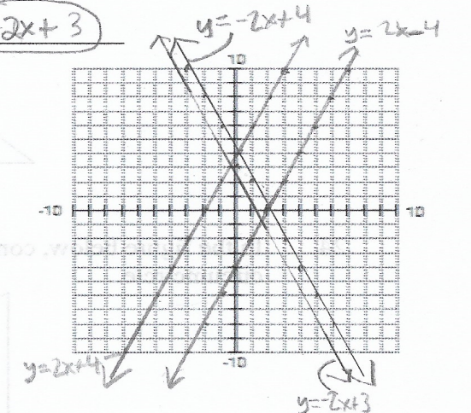
21. (a) C₁(3, 0) or C₂ (-7, 0)
(b) B₁ (7, 3) or B₂ (-6, 3)

(c) The slopes are ¹/₃ and -3, and ¹/₃ × -3 = -1.
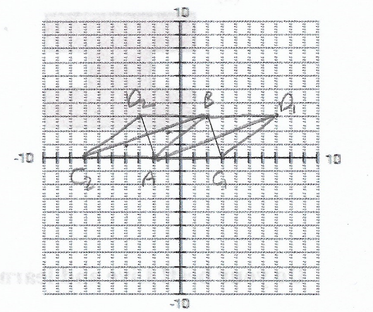
(d)

22. (a) I (b) G (c) C (d) H

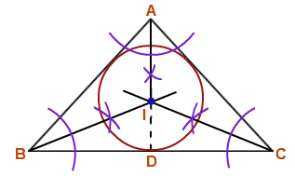
23.

24.

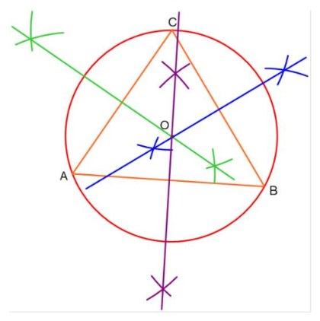

25. (a) Yes (b) Yes (c) No

