Teach Like Your Hair’s On Fire by Rafe Esquith Problems
Citation: Esquith, R. (2007). Teach like your hair's on fire: The methods and madness inside room 56. Penguin.
The Game of Buzz
Choose a “taboo digit” from 1 to 9. Then count consecutively 1, 2, 3, 4, …, replacing the digit you’ve chosen with the word buzz. Everyone participates in this fun activity.
For instance, if the taboo number is 6, the class would count:
1, 2, 3, 4, 5, buzz, 7, 8, 9, 10 , 11, buzz (12 is a multiple of 6),
13, 14, buzz (since 1 + 5 = 6), buzz (since 16 has a 6) 17, buzz, 19, 21, 22,
buzz (since 2 x 3 = 6), buzz (since 24 is a multiple of 6), and so on.
Any digit can be selected, prime or composite or perfect squares can be selected, etc.
Mental Math Activities
1. Start with the number of states in the United States of America. (50)
Add a dozen. (Now they are adding 12 to get 62.)
Then subtract the number of Supreme Court justices. (Subtract 9 to get 53.)
Add the number of weeks in a fortnight which is how long the Wimbledon tournament lasts. (Add 2 to get 55).
Divide by 11 and show me your answer. (Everyone gets 5.)
2. Start with the number of pints in a gallon. (8)
Add the number of innings in a typical MLB game. (Add 9; the result is 17.)
Multiply by the number of millimeters in a centimeter. (Multiply by 10; the result is 170.)
Subtract the number of U.S. senators. (Subtract 100; the result is 70.)
Subtract a half-dozen. (Subtract 6; the result is 64.)
Show me the square root of this number. (Everyone gets 8.)
Marcy Cook Tile Problems (http://marcycookmath.com/)
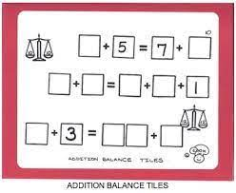
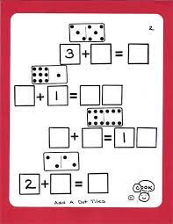
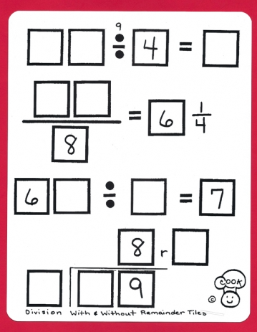
Use the numbers 0-9, each digit only once to complete these problem sets.

