The Distance Formula
The distance formula can be obtained by creating a triangle and using the Pythagorean Theorem to find the length of the hypotenuse. The hypotenuse of the triangle will be the distance between the two points.
The subscripts refer to the first and second points; it doesn't matter which points you call first or second.
x₂ and y₂ are the x and y coordinates for one point
x₁and y₁ are the x and y coordinates for the second point
d is the distance between the two points
The Distance Formula
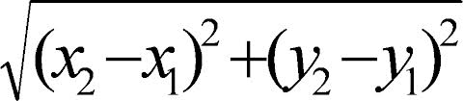
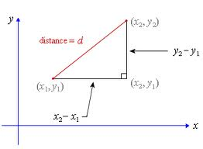

The Midpoint Formula
