**Unit IV Journal — Chapters 7 & 8 Name ____________________**

Respond to each item, giving sufficient detail. Neatly handwrite your responses. *This should be very helpful to you as you prepare for exams.*

1. The three types of probability are:

(1) theoretical (classical) (2)

(3)

Give the classical probability formula for the **probability of any event** A, using S for the sample space with all equally likely outcomes.

P(A) =

The probability of an event is always between and .

If A represents any event, the probability that event A does not occur is . Using the given probability of an event, find the probability that it does not occur.

1 35%

6

0.9

2. Two events are **independent** if the outcome of one does not affect the probability of the other event. Consider two independent events, A and B, with individual probabilities, P(A) and P(B). The probability that A and B occur together is

P(A and B) =

For example, toss 2 coins. Find the probability of a “head” on both.

Two events are if the outcome of one affects the probability of the other event. The probability that dependent events A and B occur together is

P(A and B) =

where P(B given A) means “the

probability of event B given the occurrence of event A.”

For example, a bag contains five red balls and eight white balls. If you select 2 balls at random without replacement, find the probability that you get 1 red ball and 1 white ball.

3. Complete the formulas below, and draw a Venn diagram to illustrate each rule.

For events that are **non-overlapping** (mutually exclusive), P(A or B) =

For events that are **overlapping** (i.e., they can occur together),

P(A or B) =

4. (a) A town is growing by 5,000 more people every year. This is an example of __________ growth (linear or exponential). If the town has a current population of 235,000 and this steady growth continues, what will the town’s population be in 2 years? Show your work below.

(b) A town is growing by 5% each year. This is an example of __________ growth (linear or exponential). If the town has a current population of 235,000 and this growth continues, what will the town’s population be in 2 years? Show work.

5. Find a function rule for the following data tables.

|  |  |
| --- | --- |
| ***x*** | ***y*** |
| -2 | -6 |
| -1 | -2 |
| 0 | 2 |
| 1 | 6 |
| 2 | 10 |
| 3 | 14 |

y = ____________________ f(x) = ____________________

|  |  |
| --- | --- |
| ***x*** | ***f(x)*** |
| -2 | 1/9 |
| -1 | 1/3 |
| 0 | 1 |
| 1 | 3 |
| 2 | 9 |
| 3 | 27 |

6. For a quantity growing exponentially at a rate of P% per time period, the doubling time is

Tdouble ≈ _______________

This approximation works best for small growth rates and breaks down for rates over about 15%.

For example, if the APR is 5%, the approximate doubling time is __________ years.

If the APR is 10%, the approximate doubling time is __________ years.

For a quantity decaying exponentially at a rate of P% per time period, the half-life is given by the formula

Thalf ≈ _______________

This approximation works best for small decay rates and breaks down for rates over about 15%. The exact formulas both involve logarithms. True or False. __________

7. Match the following graphs with their corresponding function type.

(a) logistic _____

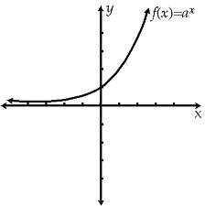

1

(b) exponential _____

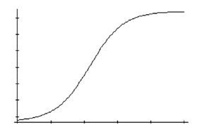

2

Consider a population that begins growing exponentially at a base rate of 4.0% per year and then follows a logistic growth pattern. If the carrying capacity is 40 billion, find the actual growth rate when the population is 10 billion.

Use the formula: 

8. Label the following graphs with the corresponding equations from the following list:  
  
 y = 5x , y = x, and 

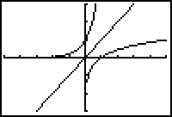

y = 5x

Complete the following chart of logarithm rules, along with their rationale.

|  |  |
| --- | --- |
| 1. logaa = 1 because __________ . | 5. loga_____ = logaM + logaN  since aM ∙ aN = aM+N. |
| 2. __________ because a0 = 1. | 6. ___    since = aM−N . |
| 3. logaar = r | 7. logaMr = r ∙ logaM |
| 4. = M | 8. _______ = |

9. The compound interest formula for the accumulated amount of an investment is



Find the approximate and exact double time for an investment of $500 at an APR of 3.5% compounded annually.

(a) Approximate (b) Exact

10. Write a few sentences describing something you learned that was new for you in class this unit. You may include a favorite activity, an interesting application, a teaching and learning technique, or a specific concept that you better understand as a result of this unit.

**Do your best! Rise to the challenge! Live and learn!**