Probability Basics Name _________________________
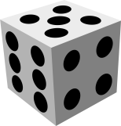
1. Roll a die once. Find the probability that the die lands on a 3 or more.
P (3 or more) = _____

2. Draw a card out of a standard deck of playing cards. Find the probability of drawing an ace.
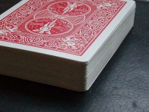
P (Ace) = _____

3. One card is drawn from a standard 52-card deck. What is the probability that it is a black face card?

4. Flip two coins.
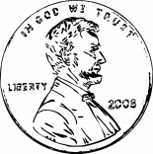
Complete the sample space for this experiment. S = {HH, _____ , _____, _____ }
Find the probability of at least one tail.

5. Toss 3 coins. Let H represent “heads” and T represent “tails”.
(a) List the outcomes in the sample space. S = { __________________________________ }

(b) Find the probability of at least one head.
P (at least one H) = _____
P (exactly two H) = _____

6. If A represents any event, the probability that event A does not occur is . Using the given probability of an event, find the probability that it does not occur.

1 40%
4

0.85 ______

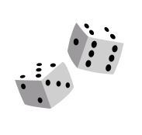
7. On a roll of two dice, Serena thinks that the sum will be 11, and Mackenzie thinks that the sum will be 3. Who has a higher chance of being correct? Multiple choice.
(a) Mackenzie (b) Serena (c) They have an equal chance of being right.
Explain your reasoning.

8. Two events are independent if the outcome of one does not affect the probability of the other event. Consider two independent events, A and B, with individual probabilities, P(A) and P(B). The probability that A and B occur together is

P(A and B) = P(A) × P(B)

For example, toss 2 coins. Find the probability of a “tail” on both.

Two events are dependent if the outcome of one affects the probability of the other event. The probability that dependent events A and B occur together is

P(A and B) = P(A) × P(B given A) where P(B given A) means “the

probability of event B given the occurrence of event A.”

For example, a bag contains five red balls and eight white balls. If you select 2 balls at random without replacement, find the probability that you get 1 red ball and 1 white ball.
9. A single letter from the word MISSISSIPPI is chosen. What is the probability of choosing an S or an I?

10. (a) What is the probability of rolling two 5’s in a row with a single die? Show your reasoning.

(b) What is the probability of rolling at least one 5 when you roll two dice? Show your reasoning.

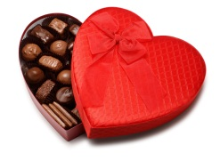
11. (a) A box of candy contains 5 dark chocolates and 5 white chocolates. If you pick randomly and eat each candy after choosing it, what is the probability of choosing three dark chocolates in a row?

(b) A box of candy contains 5 dark chocolates and 5 white chocolates. If you pick a candy randomly, record what
type of chocolate it is, then you return it to the box, what is the probability of choosing three dark chocolates
in a row?

12. Two dice are rolled. Find the probability of getting an odd number on the first die and an even number on the second die.

13. What is the probability that a card selected from a deck will be:
(a) either an ace or a spade? (b) either an ace or a face card?

14. The following table shows the student demographics for a PSYC 1101 class.
 | Male | Female
Freshman | 3 | 10
Sophomore | 4 | 9
Junior | 0 | 3
Senior | 1 | 0

(a) Find the probability that a randomly selected student from the class is a female.

(b) Find the probability that a randomly selected student from the class is a male sophomore.

(c) If you know that a Freshman was selected randomly, what is the probability that they are female?

(d) Find the probability that two randomly selected students from the class are a female junior and a male senior.

(e) Find the probability that two randomly selected students from the class are either a female junior or a male senior.

15. Out of a class of 30 students, there are 21 students who study Spanish, 16 students who study French, and 7 students who study both. What is the probability that a randomly selected student from the class will study only Spanish?

