Strip Diagrams Worksheet Name _______________
1. The big dog weighs five times as much as the little dog. The little dog weighs times as much as the medium-sized dog. The medium sized dog weighs 7 pounds more than the little dog. How much does the big dog weigh?
- Draw a strip diagram for each of the 3 quantities mentioned in the problem. Be consistent in your scaling.

(b) Solve the problem, and explain your solution process.

2. Pat and Ron split a cake. Pat’s share is ¹/₂ as large as Ron’s share.
(a) Sketch on the “cake” diagram below to show Pat’s and Ron’s shares. Label them P and R.

(b) Ron's share is ______ times as large as Pat's share.
(c) Pat's share is what fractional part of the whole cake? ______

3. Suzy and Linda split a candy bar. Suzy’s share is ²/₃ as large as Linda’s share.
(a) Sketch on the “candy bar” diagram below to show Suzy’s and Linda’s shares. Label them S and L.

(b) Linda's share is ______ times as large as Suzy's share.
(c) Suzy's share is what fractional part of the whole candy bar? ______

4. Rob and Laura split a pizza. Rob’s share is ⁵/₃ as large as Laura’s share.
(a) Sketch on the “pizza” diagram below to show Rob’s and Laura’s shares. Label them R and L. Use either shape.

(b) Laura's share is ______ times as large as Rob's share.
(c) Rob's share is what fractional part of the whole pizza? ______

(d) Laura's share is what fractional part of the whole pizza? ______

5. Three boys spend the afternoon playing a video game and then compared their best scores. Al says, “My best today is 900 points better than yours, Bob.” Carlos says, “I was having a good day. My 3,600 points is ²/₃ as much as your two scores combined, Al and Bob.” How many points did each boy get in his best game that afternoon?

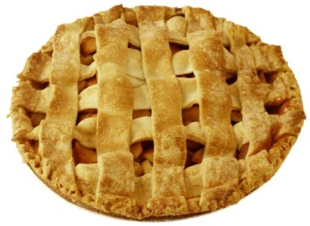
6. Three brothers, Tom (16), Dick (14), and Harry (9) were home alone and hungry. They decided to buy a whole apple pie and eat it. They chipped in their money – Tom $4, Dick $3, and Harry $2 – and Tom bought a large pie. They succeeded in eating it all. Tom ate twice as much as Harry, and Dick ate 1 ½ times as much as Harry. What fractional part of the pie did each brother eat?

