Singapore Modeling Method (SMM) Sample Problems
Whole Numbers
- Addition (Discrete)
Ramon had 3 red crayons and found 2 blue crayons in his backpack. How many total crayons does Ramon have?

- Subtraction (Discrete)
Susan had 8 pencils. She gave 3 of them away. How many pencils did she have left?

- Addition (Larger Numbers)
124 boys and 109 girls took part in an art contest. How many children took part in the contest?

- Subtraction (Larger Numbers)
A total of 438 people were at a little league football game. There were 213 children, and the remainder were adults. How many adults were at the football game?

- Subtraction (Comparison)
Khaji saved $184. Jamil saved $121. How much more money did Khaji save than Jamil?

- Ratio
The ratio of children to adults at the football game was 2:3. If there were 140 children at the football game, how many adults were there?

- Rate
Jesse roasted 12 marshmallows in 4 minutes. How many marshmallows could he roast in 7 minutes?

- Multiplication
Each student received 3 stickers on each page of his/her math journal. If there were 9 pages, how many stickers did each student receive in their journal?

- Multiplication (Comparison)
A farmer has 8 cows. He has 4 times as many chickens as cows. How many animals does the farmer have altogether?

- Division (Partitive)
Alex and Cody are playing Memory. They put 42 cards into 6 equal rows. How many cards are in each row?

- Division (Quotitive with remainders)
Ms. Taylor had 26 students in homeroom. If only 4 students can sit at each table, how many tables will Ms. Taylor need?
Fractions

- Jackie spent ²/₃ of her money at the book fair and had $10 left. How much money did she spend at the book fair?
- A pizza was cut into 6 equal pieces. Kurt ate ¹/₃ of the pizza. How many pieces were left?
- Asha had two candy bars and wanted to share ¼ of her candy with her sister, Anna. Anna’s total share was what fraction of the whole candy bar?
- Joni had ½ of a birthday cake left that she wanted to divide evenly with 3 friends. What fraction of the total cake will each friend receive?
Decimals
- Janna spent $48.69 on shorts and t-shirts. She has $13.55 left. How much money did she have at first?
- Calvin wants to buy a new Xbox game that costs $15.99. He has $8.43 right now. How much more money does Calvin need to save to buy the Xbox game?
- Students found that the teacher’s desk measured 1.3 meters long. The length of the board was 3 times as long as the teacher’s desk. What is their combined length?
- Shuntia is helping decorate the school for red ribbon week. She needs to cut a ribbon into 3 equal pieces. If the ribbon is 6.3 meters long, what should be the length of each piece?
Percentage
- Raven knows 60% of the sixth graders have dogs. If 75 sixth graders have dogs, how many students are in sixth grade?
A Bridge to Algebra
- Together, Paul and John earned a total of $64 cutting grass. If Paul earned $14 more than John, how much money did each person earn?
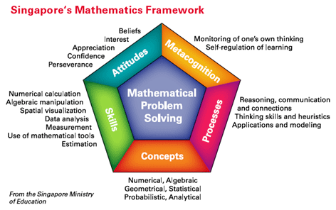
For more information, consider the following resources:
Englard, L. (2010). Raise the bar on problem solving. Teaching
Children Mathematics, 156-163.
Forsten, C. (2010). Step-by-step model drawing: Solving word problems
the Singapore way. Peterborough, NH: Crystal Springs Books.
Walker, L. (2010). Model drawing for challenging word problems: Finding solutions the Singapore way.
Peterborough, NH: Crystal Springs Books.
Hong, K. T., Mei, Y. S., & Lim, J. (2009). The Singapore model method for learning mathematics.
Singapore: EPB Pan Pacific.
Ng, S. F., & Lee, K. (2009). The model method: Singapore children's tool for representing and solving
algebraic word problems. Journal for Research in Mathematics Education, 40(3), 282-313.
http://www.symbaloo.com/mix/singaporemathresources http://www.mathplayground.com/tb_addition/thinking_blocks_addition_subtraction.html
http://www.mathplayground.com/tb_multiplication/thinking_blocks_multiplication_division.html
http://timssandpirls.bc.edu/timss2015/frameworks.html (TIMSS website: Check out the problem choices!)

