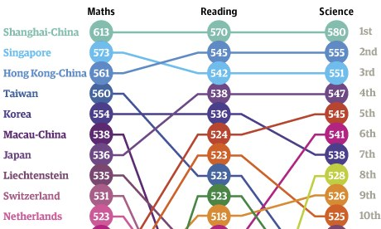
Pisa results 2012
Ranking | Country name | Maths, mean score Pisa 2012 | Reading, mean score Pisa 2012 | Science, mean score in PISA 2012
0 | OECD average | 494 | 496 | 501
1 | Shanghai-China | 613 | 570 | 580
2 | Singapore | 573 | 542 | 551
3 | Hong Kong-China | 561 | 545 | 555
4 | Taiwan | 560 | 523 | 523
5 | S.Korea | 554 | 536 | 538
6 | Macau-China | 538 | 509 | 521
7 | Japan | 536 | 538 | 547
8 | Liechtenstein | 535 | 516 | 525
9 | Switzerland | 531 | 509 | 515
10 | Netherlands | 523 | 511 | 522
11 | Estonia | 521 | 516 | 541
12 | Finland | 519 | 524 | 545
13 | Canada | 518 | 523 | 525
14 | Poland | 518 | 518 | 526
15 | Belgium | 515 | 509 | 505
16 | Germany | 514 | 508 | 524
17 | Vietnam | 511 | 508 | 528
18 | Austria | 506 | 490 | 506
19 | Australia | 504 | 512 | 521
20 | Ireland | 501 | 523 | 522
21 | Slovenia | 501 | 481 | 514
22 | Denmark | 500 | 496 | 498
23 | New Zealand | 500 | 512 | 516
24 | Czech Republic | 499 | 493 | 508
25 | France | 495 | 505 | 499
26 | UK | 494 | 499 | 514
27 | Iceland | 493 | 483 | 478
28 | Latvia | 491 | 489 | 502
29 | Luxembourg | 490 | 488 | 491
30 | Norway | 489 | 504 | 495
31 | Portugal | 487 | 488 | 489
32 | Italy | 485 | 490 | 494
33 | Spain | 484 | 488 | 496
34 | Russian Federation | 482 | 475 | 486
35 | Slovak Republic | 482 | 463 | 471
36 | USA | 481 | 498 | 497
37 | Lithuania | 479 | 477 | 496
38 | Sweden | 478 | 483 | 485
39 | Hungary | 477 | 488 | 494
40 | Croatia | 471 | 485 | 491
41 | Israel | 466 | 486 | 470
42 | Greece | 453 | 477 | 467
43 | Serbia | 449 | 446 | 445
44 | Turkey | 448 | 475 | 463
45 | Romania | 445 | 438 | 439
46 | Cyprus | 440 | 449 | 438
47 | Bulgaria | 439 | 436 | 446
48 | UAE | 434 | 442 | 448
49 | Kazakhstan | 432 | 393 | 425
50 | Thailand | 427 | 441 | 444
51 | Chile | 423 | 441 | 445
52 | Malaysia | 421 | 398 | 420
53 | Mexico | 413 | 424 | 415
54 | Montenegro | 410 | 422 | 410
55 | Uruguay | 409 | 411 | 416
56 | Costa Rica | 407 | 441 | 429
57 | Albania | 394 | 394 | 397
58 | Brazil | 391 | 410 | 405
59 | Argentina | 388 | 396 | 406
60 | Tunisia | 388 | 404 | 398
61 | Jordan | 386 | 399 | 409
62 | Colombia | 376 | 403 | 399
63 | Qatar | 376 | 388 | 384
64 | Indonesia | 375 | 396 | 382
65 | Peru | 368 | 384 | 373

