**The Weight Gain Program Tasks**

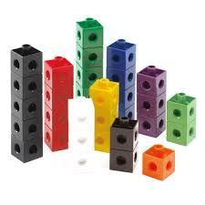[Adapted from: “Expanding Students’ Conceptions of the Arithmetic Mean” (1995) by R.A. Meyer, C. Browning, & D. Channell]

Materials: Boxes of multilink or Unifix® cubes for each group

Suggested for groups of 3 or 4 students

Procedures:

1. Suppose five teachers (Jane, David, Chris, Bob, and Kim) are participating in a weight gain, muscle-building program that requires each teacher to gain 2 pounds a week. They must try to gain these 2 pounds by eating specially formulated chocolate bars. Using various medical tests, the teachers were able to determine how many bars each would have to eat weekly in order to gain 2 pounds per week. The results of these tests are given in the figure. Suppose the teachers want to know the average number of candy bars they need to consume.

2. Next, draw a horizontal line on the graph to represent your estimate of the average number of chocolate bars the teachers would have to eat to gain 2 pounds. Now adjust the estimated average to find the actual mean. You may wish to use Unifix® cubes to represent the graph and move cubes to help you find the actual mean. Show this process below.

3. Draw this new average line on your graph.

4. After you have drawn the horizontal line on the graph to represent the actual mean, what is true about the sums of the number of candy bars above and below the line? Show that your final average is indeed the balancing number for the original candy bar data.