The Buttons Task
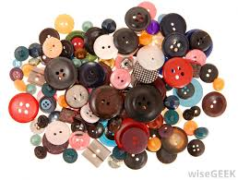
[inspired by M. Zoss’ Button Sorting Analogy in a writing workshop at GSU’s Indian Creek, October 2015]
Materials: Many buttons of various sizes, colors, textures, numbers of holes, etc.
Suggested for pairs of 2 or groups of 3 or 4 students

Procedures:
1. Sort your buttons into two groups (a K CCSSM standard). What is your rationale for this choice of categories?

Make an appropriate graph.

Which is the largest group? What statistical measure (mean, mode, median, midrange) would be associated with this category? Compare the two groups; how much more is one than the other?

2. Now re-sort your buttons into 3 or more groups. Be creative!
Rationale:

Make an appropriate graph.

Which is the largest group? What statistical measure would be associated with this category?

