The Balancing Towers Task
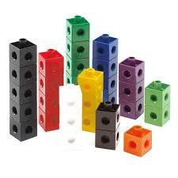
[Adapted from: “Expanding Students’ Conceptions of the Arithmetic Mean” (1995) by R.A. Meyer, C. Browning, & D. Channell]
Materials: About 50 multilink cubes for each group
Suggested for groups of 3 or 4 students

Procedures:
1. Obtain enough multilink cubes from your teacher, and make towers of the following heights:
2, 3, 5, 5, 8, 9, and 10 cubes high. Draw a picture below of these cube towers.

2. Next, you will be moving cubes from one tower to another until the towers are equal, or about equal, in height.
However, before you begin to move cubes, estimate the final height of each tower. _______

3. Now move the cubes until the towers are of the same or about the same height. What is the average height? _______

Draw a picture below of your cube towers.

4. Write a brief statement about what you learned from this activity.

