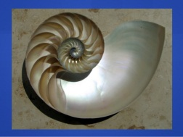
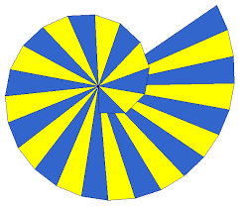
The Wheel of Theodorus Task

Look at the figure below. Start by finding the value for X1, then for X2, then X3, and so on until you get the value for X6. Write the lengths as square roots, and leave the radicals unsimplified, as that makes it simpler. What is the value of X6?

Without extending the drawing, find the value of X10.

Then, find the value of X100.

What is the general value of Xn, where n is a natural number?

