Pythagorean Theorem Problems

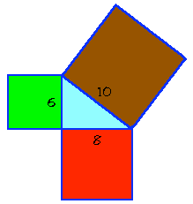(1) The Pythagoras Proof:

This is a hands-on exercise for you to convince yourself that the Pythagorean theorem works. It is based on the actual proof that is attributed to Pythagoras. On the following figure we have a right triangle with a square associated with each of its sides:

Using the dimensions associated with the squares. Then make sure that the area of the hypotenuse's square (brown) equals
the areas of the other two squares together.

Now for the hands on part. Draw an equivalent picture on a piece of paper. You can use any size triangle as long as
it is a right triangle. For the kinesthetic part, cut up and reassemble
the two small squares to form a square identical to the larger one.

(2) The classical ladder problem:

There is a building with a 12 ft high window. You want to use a ladder to go up to the window, and you decide to keep the ladder 5 ft away from the building to have a good slant. How long should the ladder be?

(3) Baseball diamond:

On a baseball diamond, the bases are 90 ft apart. What is the distance from home plate to second base in a straight line? [Also, the pitching rubber is 60'6" from home plate; is it closer to home or to second base?] Round to the nearest thousandth of a foot.

(4) Equilateral triangle:

An equilateral triangle has vertices at (0,0) and (6,0) in a coordinate plane. What are the coordinates of the third vertex? You may want to sketch it out. Give an exact simplified radical answer, when appropriate.
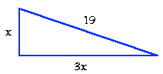

(5) An algebraic problem:

Find out the length of sides a and b on the following right triangle:

Round to the nearest thousandth’s place.
(6) An iterative problem:

Look at the following figure. Start by finding the value for X1, then for X2, then X3, and so on until you get the value for X6. Write the lengths as square roots, as that makes it simpler. What is the value of X6?

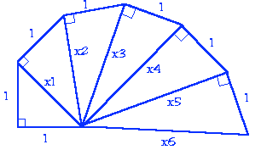

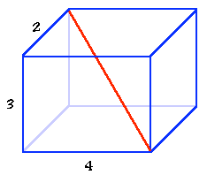(7) A 3-D problem:

We have a wooden box that measures 4 ft by 3 ft by 2 ft:

What is the longest straight pole, like the one shown, that you can have inside the box?

(8) Pythagorean Triples:

There is a simple formula that gives all the Pythagorean triples. If m and n are two positive integers and m < n, then the triples can be generated with the following equations:
a = b = 2mn c =

It's easy to check algebraically that the sum of the squares of a and b is the same as the square of c. Now try it out and produce at least 4 “triples” as you can by substituting any positive integers for m and n (as long as m < n). If you know how to use a spread sheet program (like Excel), you can very quickly do a table that generates tons of triples.

Source — http://arcytech.org/java

