Counting Parts of Solids
Name ________________________________
Figure | Number of Faces (F) | Number of Vertices (V) | Number of Edges (E)
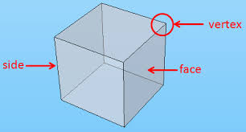
edge

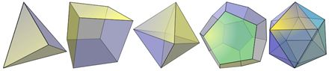

Bonus: Write a formula relating F, V, and E. _________________________________

