Changing Garden
Imagine that you are designing a rectangular garden. Also suppose that:
- You want to enclose your garden with 30 feet of wire fencing so that animals won’t eat your plants;
- You want to use all 30 feet of fencing, without any gaps or overlaps; and
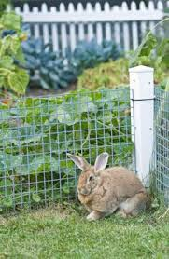
- Your fencing comes in one-foot sections that you can’t split into fractional parts.

1. What does area mean?

2. What does perimeter mean?

3. Use words, pictures, and/or numbers to describe how you would find the perimeter and area
of a rectangle of any size.

4. Determine all the different ways in which you can arrange the 30 feet of fencing around your
garden. Be sure to list the length, width, perimeter, and area of each arrangement.
Complete the chart.
Fence | Length (feet) | Width (feet) | Perimeter (feet) | Area (square feet)
A
B
C
D
E
F
G

5. Do all the possible gardens that use the 30 feet of wire fencing have the same perimeter?
Why, or why not?

6. Do all the possible gardens that use the 30 feet of wire fencing have the same area? Why, or
why not?

7. Which dimensions give the most area?

This activity is loosely based on ideas in Lappan, G., Fey, J. T., Fitzgerald, W. M., Friel, S. N., & Phillips, E.D. (1998). Covering and surrounding: Two-dimensional measurement. Connected Mathematics Program. Palo Alto, CA: Dale Seymour. The source was Navigating through Measurement in Grades 3-5 (pp. 130-131)

