**Fraction Exploration**

1. Consider the line segment AB below:

A

B

Draw a line segment that is 1 unit long if line segment AB represents

(a)  unit

(b)  unit

(c)  units

2. True or False. If true, can the statement be somehow generalized? Explain.

If false, explain your reasoning.

(a) 

(b) 

(c) 

3. Find three different rational numbers between  and . Explain your reasoning.

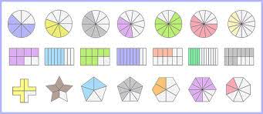4. Refer to the diagram.

(a)-(g)

(h)-(n)

(o)-(u)

For each, write the fraction for each shaded region. Assume each circle (top row), each rectangle (middle row), and each polygon (bottom row) represent 1 whole unit.

If the fraction simplifies, also write the simplified or reduced fraction. Show why this makes sense on the diagram.

(a) (b) (c) (d) (e) (f) (g)

(h) (i) (j) (k) (l) (m) (n)

(o) (p) (q) (r) (s) (t) (u)

5. Complete the following number patterns, and describe the pattern in a sentence.

(a) , ____ , ____ , ____ (b) ____ , ____ , ____