Additive and Multiplicative Comparison Tasks
Refer to each diagram. Answer the question, and give your reasoning.
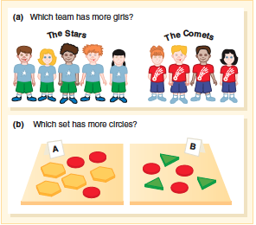
Source: Van De Walle, J., Karp, K., & Bay-Williams, J. (2016). Elementary and middle school mathematics: Teaching developmentally (2016). Pearson. 9th edition.

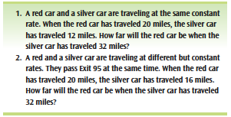
How are these two tasks alike, and how are they different? Answer each question, and show your reasoning.

