Three Balanced Scales Task
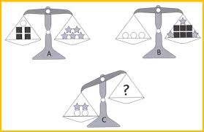

Use scales A and B to figure out how many squares would make scale C balanced. Explain your reasoning.

